AI-Driven Tourist Guide for Personalized Travel Planning and Navigation
A Project Report Submitted in the partial fulfilment of the requirements for the award of the degree of

BACHELOROFTECHNOLOGY
In
DEPARTMENT OF COMPUTER SCIENCE ENGINNERING

J. HANSIKA | :2520030060
B. NIKITA | :2520030172
N. RISHIKA CHOWDARY | :2520030212
Under the Esteemed Guidance of
Dr. D. Ramya Krishna

Assistant Professor

Department of Computer Science and Engineering

K L (Deemed to be) University DEPARTMENT OF COMPUTER SCIENCE ENGINEERING

Declaration
We hereby declare that the project report entitled “AI-Driven Tourist Guide for Personalized Travel Planning and Navigation “ is a record of the work carried out for the project and submitted in partial fulfillment of the requirements for the award of the Bachelor of Technology degree. The report has been prepared based on the project concept, features, technology stack, architecture, and expected output presented in the project presentation.

J.HANSIKA – 2520030060
B.NIKITHA– 2520030172
N.RISHIKA CHOWDARY – 2520030212

K L (Deemed to be) University
DEPARTMENT OF COMPUTER SCIENCE ENGINEERING

CERTIFICATE
This is to certify that the project report entitled “AI-Driven Tourist Guide for Personalized Travel Planning and Navigation” is a Bonafide project work submitted by J. HANSIKA- 2520030060, B. NIKITA - 2520030172, N. RISHIKA CHOWDARY - 2520030212
in partial fulfilment of the requirements for the award of the degree of BACHELOR OF TECHNOLOGY in Department of Computer Science Engineering, K L (Deemed to be University), during the academic year 2026-2027.
Signature of the Guide
Signature of the Course Coordinator Signature of the HOD

ACKNOWLEDGEMENT
The successful completion of this project would not have been possible without the timely help, valuable guidance, and support rendered by many people. I would like to express my sincere thanks and gratitude to all those who have assisted me directly or indirectly in the successful completion of my project titled “TOURIST GUIDE – An Offline-First Intelligent Travel Assistance System.”
I express my greatest appreciation to my Course Coordinator, Dr. R. Sateesh Kumar and my Project Guide, Dr. D. Ramya Krishna, Department of Computer Science, for their valuable guidance, continuous encouragement, support, and constructive suggestions throughout the development of this project. Their guidance helped me understand the requirements of the system and successfully implement the major components of the Tourist Guide application, including offline maps, POI exploration, AI-based itinerary assistance, emergency information, booking links, and the trip journal.
I express my sincere gratitude to Dr. P. Venkateshwara Rao (CSE) Head of the Department of Computer Science Engineering, for providing the necessary facilities, resources, and support required for completing this project-based work successfully.
I would also like to thank all the teaching and non-teaching staff members of the department for their valuable assistance, encouragement, and cooperation during the course of this project. I am grateful to everyone who supported me directly or indirectly in completing the Tourist Guide – An Offline-First Intelligent Travel Assistance System.
Finally, I sincerely thank my parents, friends, and classmates for their constant encouragement, cooperation, and support throughout the development and completion of this project.
J. HANSIKA – 2520030060
B. NIKITA– 2520030172
N. RISHIKA CHOWDARY – 2520030212

Abstract
Tourists travelling to unfamiliar destinations often face difficulties when internet connectivity is poor or unavailable. Dependence on online maps and travel applications can make navigation, discovery of nearby services, itinerary planning, and access to emergency information difficult. The Tourist Guide project proposes an offline-first intelligent travel assistance system designed to provide essential travel features even with limited or no internet connectivity.
The proposed Android application combines offline city map packs, a Point of Interest (POI) Explorer, an AI itinerary chatbot, offline emergency information, booking links, a Trip Journal, and locally stored travel information. The technology stack presented for the system includes Android and Kotlin for the frontend, Mapbox SDK and Mapbox Offline for maps, Room Database for local storage, Retrofit for networking, an LLM API for AI functionality, Android Studio for development, and Git/GitHub for version control.
The expected outcome is a user-friendly Android tourist guide capable of supporting navigation, local discovery, personalized itinerary generation, emergency access, external booking connections, and travel journaling while maintaining useful functionality in low-connectivity environments.

Index
S.  No. | Chapters | Topics | Page.no
 |  | Acknowledgement
 |  | Abstract
1 | Introduction | 1.1 Background of the project  1.2 Problem statement  1.3 Scope of the project  1.4 Objective(s)  1.5 Importance of the application  1.6 Target users/audience | 5-15
2 | System Requirements | 2.1 Hardware requirements  2.2 Software requirements  2.3 Development tools and frameworks | 16-21
3 | Technology Stack | 3.1 Front-end  3.2 Maps  3.3 Database  3.4 Networking  3.5 Development and Version Control | 22-32
4 | System Architecture | 4.1 High-level architecture  4.2 Architecture Components;  4.3 Working Flow | 33-36
5 | Design | 5.1 Application Design  5.2 Local Data Design  5.3 Offline-First Design | 37
6 | Implementation | 6.1 Module-wise Implementation  6.2 Offline Maps  6.3 POI Explorer;  6.4 AI Itinerary Chatbot;  6.5 Emergency Information;  6.6 Booking Links;  6.7 Trip Journal | 38-47
7 | Features | 7.1 Main Features  7.2 User Perspective  7.3 Technical Perspective | 48-55
8 | Testing | 8.1 Testing Approach  8.2 Module Testing  8.3 Offline Testing  8.4 Test cases and results | 56-64
9 | Deployment | 9.1 Android Deployment  9.2 Environment configuration  9.3 Release Considerations | 65-73
10 | Challenges &  Limitations | 10.1 Issues faced during development  10.2 Solutions applied  10.3 Current limitations or known bugs | 74-82
11 | Future Enhancements | 11.1 Planned features  11.2 Possible integrations | 83-88
12 | Conclusion | 12.1 Summary of the project  12.2 What was achieved  12.3 Skills learned during development | 89-97
13 | References | - Technology and development references | 98-99

14 | Appendices | - Screenshots of the app  - Architecture  - Setup notes  - User guide | 100-105

CHAPTER -1 INTRODUCTION
1.1 Background of the Project
Tourism is an important part of modern society, providing people with opportunities to explore new places, experience different cultures, visit historical and natural attractions, and create memorable travel experiences. With the rapid development of smartphones and mobile applications, travelers increasingly depend on digital technology for navigation, destination discovery, travel planning, emergency assistance, and other travel-related activities.
Most modern travel applications depend heavily on an active internet connection. Online maps, search engines, travel websites, recommendation systems, and many other digital services require continuous connectivity to provide information to travelers. Although internet connectivity is widely available in cities and developed areas, travelers may frequently encounter situations where network connectivity is weak, unavailable, expensive, or unreliable. Such situations can occur in remote tourist locations, rural areas, hilly regions, underground locations, during network congestion, or while travelling internationally.
The Tourist Guide – An Offline-First Intelligent Travel Assistance System is proposed to address these difficulties by providing important travel assistance even when internet connectivity is limited or unavailable. The project is designed as an Android-based application using Kotlin, with Mapbox for mapping and offline map support, Room Database for local data storage, Retrofit for network communication, and an LLM API for intelligent itinerary generation.
The central idea of the project is the offline-first approach. Instead of treating internet connectivity as a permanent requirement, the system stores important travel information locally so that users can continue to access essential features when they are offline. Downloadable city map packs allow users to access maps without depending continuously on network connectivity. Similarly, emergency information and selected travel information can be stored locally for later access.
The application also combines multiple travel-related functions into a single mobile environment. The proposed system includes an Offline Map Pack, POI Explorer, AI Itinerary Chatbot, Emergency Information, Booking Links, and Trip Journal. These features are intended to reduce the need for travelers to switch between multiple applications while travelling.
The POI Explorer helps users discover different categories of useful places such as tourist attractions, restaurants, hotels, hospitals, ATMs, and transportation facilities. This allows the application to function not only as a navigation tool but also as a local travel information system.
Another important component is the AI Itinerary Chatbot. The system uses an LLM API to generate personalized travel plans based on information such as available time, interests, and preferences. Instead of requiring users to manually organize every activity, the chatbot can assist in structuring a travel itinerary.
The Emergency Information feature provides important emergency contacts and essential service information that can be accessed without depending on an active internet connection. This is particularly useful when a traveler faces connectivity problems and needs quick access to essential information.
The Trip Journal feature allows users to maintain a personal record of visited places, notes, and travel memories. Therefore, the project combines navigation, destination discovery, intelligent planning, emergency assistance, external booking access, and travel journaling into a single Android application.
Overall, the project demonstrates how mobile computing, offline data storage, digital mapping, network communication, and artificial intelligence can be combined to create a travel assistance system that is more useful in situations where continuous internet access cannot be guaranteed.
1.2 Problem Statement
Tourists travelling to unfamiliar destinations often face several practical difficulties. One of the most significant problems is poor or unavailable internet connectivity. Many existing travel applications are primarily designed around online services, meaning that users may lose access to maps, search results, recommendations, and other important information when connectivity is interrupted.
The project identifies the following major problems:
- Poor or unavailable internet connectivity: Travelers may visit areas where mobile data or Wi-Fi is weak or unavailable.
- Dependence on online maps and travel applications: Conventional applications may require a continuous connection for map loading, searching, and navigation.
- Difficulty discovering nearby local attractions and services: Travelers may not know what attractions, restaurants, hotels, hospitals, ATMs, or transport facilities are available nearby.
- Lack of personalized itinerary planning: Users may find it difficult to organize available travel time according to their interests and preferences.
- Difficulty accessing emergency information while offline: Important emergency contacts and essential service information may not be readily available when internet access is interrupted.
- Dependence on multiple applications: A traveler may need one application for maps, another for restaurants, another for itinerary planning, another for bookings, and another for maintaining travel memories.
These problems create unnecessary complexity during travel. The user may need to repeatedly search for information, change between applications, and depend on network availability.
The proposed Tourist Guide application attempts to reduce these problems by providing an integrated travel assistance environment with an offline-first design.
1.3 Scope of the Project
The scope of the Tourist Guide project focuses on developing an Android mobile application capable of providing essential travel assistance both online and offline.
The major areas covered by the project are:
Offline Navigation
The application supports downloadable city map packs through Mapbox Offline functionality. Users can download required map information in advance and use the stored map resources when internet connectivity is unavailable.
Point of Interest Exploration
The POI Explorer provides information about categories of locations that may be useful to tourists. These include attractions, restaurants, hotels, hospitals, ATMs, and transportation facilities.
Intelligent Itinerary Planning
The application integrates an LLM API to provide an AI-based itinerary chatbot. Users can provide travel-related requirements such as available time and interests, and the system can generate a corresponding travel plan.
Emergency Assistance
Important emergency contacts and essential travel information can be made available locally so that the user can access them without depending completely on an internet connection.
External Booking Access
The application provides booking links that connect users to external booking services. The Tourist Guide application acts as a travel assistance interface rather than necessarily performing the booking transaction itself.
Travel Journal
Users can maintain a record of visited places, notes, and travel experiences using the Trip Journal functionality.
Local Data Storage
Room Database is used as the local database technology for storing application information that needs to remain available on the device.
The project does not claim that every feature is completely independent of internet connectivity. In particular, external services and the LLM API may require network access when fresh online information or AI responses are requested. The offline-first design primarily ensures continued access to information and functions that have been previously downloaded or stored locally.
1.4 Objectives
The primary objective of the Tourist Guide project is to develop an Android-based travel assistance application that provides useful travel functionality even in limited-connectivity environments.
The major objectives are:
- To develop an Android application using Kotlin.
- To provide offline-accessible city maps using Mapbox Offline functionality.
- To help users discover nearby tourist attractions and essential facilities.
- To provide a POI Explorer covering categories such as attractions, restaurants, hotels, hospitals, ATMs, and transport facilities.
- To develop an AI itinerary chatbot using an LLM API.
- To generate personalized travel plans according to user-provided requirements.
- To provide offline-accessible emergency information.
- To provide links to external booking services.
- To provide a Trip Journal for recording visited places and travel memories.
- To store important local travel information on the device.
- To reduce dependence on multiple separate travel applications.
- To demonstrate the practical use of mobile development, offline databases, mapping technologies, networking, and artificial intelligence.
1.5 Importance of the Application
The importance of the Tourist Guide application lies primarily in its focus on situations where internet connectivity cannot always be guaranteed.
A conventional online travel application may become less useful when the user loses connectivity. An offline-first application addresses this issue by allowing important information to be prepared and stored before the journey. This approach is particularly relevant for travelers visiting remote locations, areas with weak network coverage, or destinations where connectivity may be expensive or inconsistent.
The application also improves the organization of travel-related information. Instead of using separate applications for navigation, destination discovery, itinerary planning, emergency information, and travel journaling, users can access these functions through one application.
The project is also significant from an academic and technical perspective. It demonstrates the integration of several areas of computer science, including:
- Android application development
- Kotlin programming
- Database management
- Offline data storage
- Digital mapping
- API integration
- Artificial intelligence
- User interface design
- Software testing
- Version control
The project therefore represents a practical application of software engineering concepts to a real-world problem.
1.6 Target Users / Audience
The primary users of the Tourist Guide application are travelers and tourists who need convenient access to travel information.
The target audience includes:
- Individual tourists
- Students travelling to new locations
- Families travelling to unfamiliar destinations
- Solo travelers
- Adventure and nature travelers
- Domestic tourists
- Travelers visiting locations with limited network connectivity
- Users who prefer maintaining a digital travel journal
The application can also be useful for users who want a single application for navigation, local discovery, itinerary planning, emergency information, and travel records.

CHAPTER – 2 SYSTEM REQUIREMENTS
2.1 Hardware Requirements
The hardware requirements define the physical devices and resources necessary for the development, testing, and operation of the Tourist Guide application. Since the application is designed as an Android-based intelligent travel assistance system with mapping, location-based services, and offline capabilities, both a suitable development system and an Android device are required.
2.1.1 Development System
A computer or laptop is required for developing and maintaining the Android application. The development system should have sufficient processing and memory capacity to run Android Studio, compile the application, manage project files, install required software development kits, and perform application testing. A modern multi-core processor with a minimum of 8 GB RAM is recommended, although higher RAM is preferable when an Android emulator is used. Adequate SSD or hard-disk storage is also required for Android Studio, SDK components, Gradle dependencies, project files, and other development resources. Standard peripherals such as a keyboard and mouse are required for development activities. A stable internet connection is also necessary for downloading dependencies, SDK components, map resources, accessing online APIs, and synchronizing project resources.
2.1.2 Android Device
The Tourist Guide application is intended to operate on an Android smartphone or another compatible Android device. The device should have a supported Android operating system, sufficient internal storage, and a display capable of presenting maps, travel information, and application interfaces clearly. Since the application includes location-based and navigation-related functionality, the Android device should provide GPS or other location services. Adequate storage capacity is also important because offline map resources and locally stored application data may occupy additional storage space. Network connectivity is required for features that communicate with external services, while selected application functions can continue to operate using locally available data when an internet connection is unavailable.
2.1.3 GPS and Location Services
GPS and location services form an important part of the Tourist Guide application because location information can be used to support navigation, identify the user's current position, and discover nearby tourist destinations and services. When location-based functionality is required, the application requests the appropriate permissions from the user in accordance with Android's permission system. The accuracy and availability of location information depend on the capabilities of the user's device, GPS signal strength, network conditions, and surrounding environmental factors.
2.2 Software Requirements
The software requirements describe the development platforms, programming languages, libraries, databases, APIs, and supporting tools required to develop and operate the Tourist Guide application. The software architecture combines Android development technologies with mapping, local storage, network communication, and artificial intelligence services to provide an intelligent and offline-first travel experience.
Android Operating System
Android is the target mobile platform for the Tourist Guide application. It provides the operating environment in which the application is installed and executed. Android also provides built-in support for important functionalities such as location services, application permissions, local storage, network communication, and device hardware integration.
Android Studio
Android Studio is used as the primary Integrated Development Environment (IDE) for developing the application. It provides the necessary environment for writing and managing Kotlin source code, designing application interfaces, configuring Android SDK components, managing Gradle dependencies, building application packages, debugging the application, and testing it using physical Android devices or emulators. Android Studio also provides Logcat facilities that help developers monitor application behaviour and identify runtime errors during development.
Kotlin
Kotlin is used as the primary programming language for the Android application. It is a modern programming language officially supported for Android development and provides features such as concise syntax, null safety, object-oriented programming, functions, and structured application development. Kotlin enables the implementation of the application's user interface, business logic, database operations, API communication, and integration with other Android services.
Mapbox SDK
The Mapbox SDK is used to provide digital mapping and map visualization capabilities within the application. It enables the application to display interactive maps, locations, routes, and other geographic information. Mapbox is particularly relevant to the project because the application follows an offline-first approach and requires mapping functionality that can continue to support users when network connectivity is limited or unavailable.
Mapbox Offline
Mapbox Offline functionality is used to support offline map access. It allows required map resources to be made available locally on the Android device so that users can continue to access selected geographic information without continuously depending on an internet connection. This capability is particularly useful for travellers who may experience poor or unavailable network connectivity in certain locations.
Room Database
Room Database is used as the local persistence layer of the application. It provides a structured method for storing application data directly on the Android device. The database can be used to maintain information that needs to remain accessible during offline operation, reducing the application's dependency on continuous network connectivity. Room also provides a convenient abstraction over SQLite and supports structured database operations within the Android application.
Retrofit
Retrofit is used to handle communication between the Android application and external REST-based services. It provides a structured mechanism for sending requests to APIs, receiving responses, and converting those responses into usable application data. Retrofit helps simplify network communication and allows external services to be integrated into the application's functionality.
LLM API
An LLM (Large Language Model) API is integrated to provide the intelligent itinerary and chatbot functionality of the application. The application can send relevant travel requirements, such as destination preferences, duration, interests, and other user inputs, to the language model service. The generated response can then be processed and presented to the user as a personalized travel plan or conversational travel assistance. This component adds an intelligent layer to the application and supports dynamic itinerary generation.
Git and GitHub
Git is used as the version control system for managing the application's source code and tracking changes made during development. It allows developers to maintain different versions of the project and provides mechanisms for managing and recovering previous changes. GitHub can be used as the remote repository for storing and managing the project source code. It also facilitates collaboration, code backup, project sharing, and version management among development team members.
2.3 Development Tools and Frameworks
The Tourist Guide application is developed using a combination of mobile development, mapping, database, networking, artificial intelligence, and version-control technologies. Android serves as the target mobile platform, while Kotlin is used to implement the application logic and functionality. Android Studio provides the primary development environment for designing, coding, building, debugging, and testing the application.
For mapping and navigation-related functionality, Mapbox SDK is used to display digital maps and geographic information, while Mapbox Offline supports access to selected map resources without requiring continuous internet connectivity. Room Database is responsible for maintaining structured local data on the Android device, supporting the application's offline-first design.
For communication with external services, Retrofit provides the network communication layer through REST-based APIs. The LLM API provides artificial intelligence capabilities for the itinerary chatbot and personalized travel-plan generation. Finally, Git and GitHub are used for source-code version control, project management, collaboration, and maintaining different versions of the application.
Overall, these technologies work together to create an intelligent, location-aware, and offline-first Tourist Guide application. The combination of Android and Kotlin provides the mobile application foundation, Mapbox provides mapping and offline geographic functionality, Room supports local data persistence, Retrofit enables communication with external services, and the LLM API provides intelligent travel assistance and itinerary generation.

CHAPTER – 3 TECHNOLOGY STACK
3.1 Front-End – Android and Kotlin
The front-end of the Tourist Guide system is implemented as an Android mobile application that provides the primary interface through which users interact with the various features of the system. Android serves as the target mobile platform, while Kotlin is used as the primary programming language for implementing the application logic and user interface.
The front-end is responsible for accepting user inputs and presenting travel-related information in an organized and user-friendly manner. It provides interfaces for displaying interactive maps, exploring points of interest, generating AI-based itineraries, accessing emergency information, viewing booking-related links, and maintaining a personal Trip Journal. The application is designed with a focus on simplicity and accessibility because tourists may use the system while walking, travelling, or navigating unfamiliar locations. Therefore, important travel information should be presented clearly without requiring excessive navigation between screens.
The application can organize its major functionalities into logical sections such as Home, Maps, POI Explorer, AI Itinerary, Emergency, Bookings, and Trip Journal. Each section provides access to a specific category of travel assistance while maintaining a consistent user experience throughout the application. The front-end communicates with local storage and external services depending on the requirements of each feature. Local information can be retrieved from the Room database, while online services can be accessed through the networking layer when an internet connection is available.
3.2 Mapping – Mapbox SDK and Mapbox Offline
Mapping is one of the central components of the Tourist Guide application because geographical information is essential for navigation, destination discovery, and location-based travel assistance. The Mapbox SDK is integrated into the Android application to provide interactive digital maps and enable users to visualize geographical locations, destinations, routes, and points of interest.
A key characteristic of the proposed system is its offline-first approach. Travellers may frequently experience limited or unavailable internet connectivity, particularly when visiting unfamiliar locations or areas with poor network coverage. To address this limitation, Mapbox Offline functionality is used to support downloadable map resources. Users can select a city or geographical region while an internet connection is available, after which the required map resources can be downloaded and stored for later use.
Once the required map data has been downloaded, the application can continue to provide map-related information when the user enters an area with limited or no internet connectivity. This approach reduces the application's dependence on continuous network access and improves the availability of navigation-related information during travel. As a result, the Tourist Guide system functions not only as an online mapping application but also as an offline-first travel assistance platform.
3.3 Database – Room Database
Room Database is used as the local persistence layer of the Tourist Guide application. Since offline accessibility is an important requirement of the system, information that may be required during travel should not depend entirely on an external server or continuous internet connectivity. Storing relevant information locally allows the application to remain useful even when network access is temporarily unavailable.
Room provides an abstraction layer over SQLite and allows structured data to be stored and accessed within the Android application. It also provides a convenient approach for defining database entities, performing queries, and managing locally stored application information.
Depending on the final implementation, the local database may contain information such as saved places, Trip Journal entries, user notes, downloaded travel information, emergency-related information, locally available points of interest, and user preferences. The exact database entities and fields can be defined according to the final requirements and implementation of the system.
The database layer supports fundamental operations such as inserting, updating, retrieving, searching, and deleting records. By maintaining important information locally, Room improves data availability and contributes to the overall offline-first architecture of the Tourist Guide application.
3.4 Networking – Retrofit
Retrofit is used as the networking layer for communication between the Android application and external REST-based APIs. While several features of the Tourist Guide application can operate using locally stored information, certain services require communication with external systems. These may include AI-based itinerary generation and other online travel-related services.
The general communication process can be represented as:
Android Application → Retrofit → External API → Response → Application UI
When an online service is required, the Android application sends an appropriate request through Retrofit. The external API processes the request and returns a response, which is then handled by the application and presented to the user through the appropriate interface.
Network connectivity is an important consideration in the design of the Tourist Guide application. Therefore, the application should distinguish between operations that can be performed using locally available information and those that require an active internet connection. This separation allows the system to maintain useful functionality during periods of limited connectivity while still providing advanced online services when a network connection is available.
3.5 Artificial Intelligence – LLM API
Artificial intelligence is incorporated into the Tourist Guide system through an LLM (Large Language Model) API. The AI component is primarily used to provide an intelligent itinerary chatbot that assists users in creating personalized travel plans according to their requirements.
Unlike a fixed itinerary system that provides the same predefined plan to every user, the AI-based approach allows the application to consider different user requirements. These requirements may include the user's destination, available travel time, interests, preferred activities, and other travel preferences. The collected requirements are sent to the LLM service, which generates an appropriate itinerary that is then processed and displayed within the Android application.
The overall interaction can be represented as:
User Requirements → LLM API → Generated Itinerary → Android Application
For example, a traveller can provide the destination, available duration, and preferred activities. The application can send these requirements to the LLM service and present the generated itinerary to the user in an understandable format. This provides a more personalized travel-planning experience and reduces the effort required to manually organize destinations and activities.
The AI component is intended to function as a travel planning and assistance tool rather than a replacement for the user's own decisions. The usefulness and accuracy of the generated itinerary depend on the information provided by the user, the capabilities of the selected language model, and the external information available to the service. Therefore, generated recommendations should be considered as assistance for planning rather than guaranteed or authoritative travel information.
3.6 Android Studio
Android Studio is used as the primary Integrated Development Environment (IDE) for developing the Tourist Guide application. It provides a complete environment for writing Kotlin code, designing application interfaces, managing Android SDK components, configuring project dependencies, building application packages, and testing the application.
Android Studio also provides tools for debugging application behaviour and identifying errors during development. Features such as Gradle build management, Android Emulator, Logcat, dependency management, SDK integration, and application packaging support the complete development lifecycle of the project.
Using Android Studio as the central development environment allows the developers to implement, compile, test, debug, and package the Tourist Guide application within a single integrated workspace.
3.7 Git and GitHub
Git is used as the version control system for managing the source code of the Tourist Guide application. During software development, multiple changes are made to application files, configuration files, and other project resources. Git allows these changes to be tracked systematically and provides a history of modifications made throughout the development process.
GitHub can be used as the remote repository for storing and managing the project's source code. It provides a centralized location from which authorized developers can access the project and collaborate on its development. Version control also makes it possible to maintain previous versions of the application, identify changes between different stages of development, and recover earlier versions when required.
The use of Git and GitHub therefore supports organized development, source-code management, collaboration, and maintenance of the project throughout its development lifecycle.
3.8 Technology Integration
The technologies used in the Tourist Guide application work together as an integrated system rather than functioning as independent components. Android and Kotlin provide the foundation for the mobile application and handle the user interface and core application logic. The Mapbox SDK provides interactive mapping capabilities, while Mapbox Offline supports access to downloaded map resources when network connectivity is unavailable.
The Room Database provides local data persistence and allows important application information to remain available on the device. Retrofit acts as the communication layer between the Android application and external REST-based services. The LLM API adds artificial intelligence capabilities by enabling personalized itinerary generation and chatbot-based travel assistance. Git and GitHub support version control and source-code management throughout the development process.
Through this integrated architecture, the Tourist Guide application combines mobile application development, digital mapping, offline data availability, API-based communication, and artificial intelligence to provide a comprehensive travel assistance system. The combination of these technologies supports the project's primary objective of providing users with accessible, intelligent, and reliable travel assistance even in situations where continuous internet connectivity may not be available.

CHAPTER -4 SYSTEM ARCHITECTURE

4.1 High-level architecture diagram
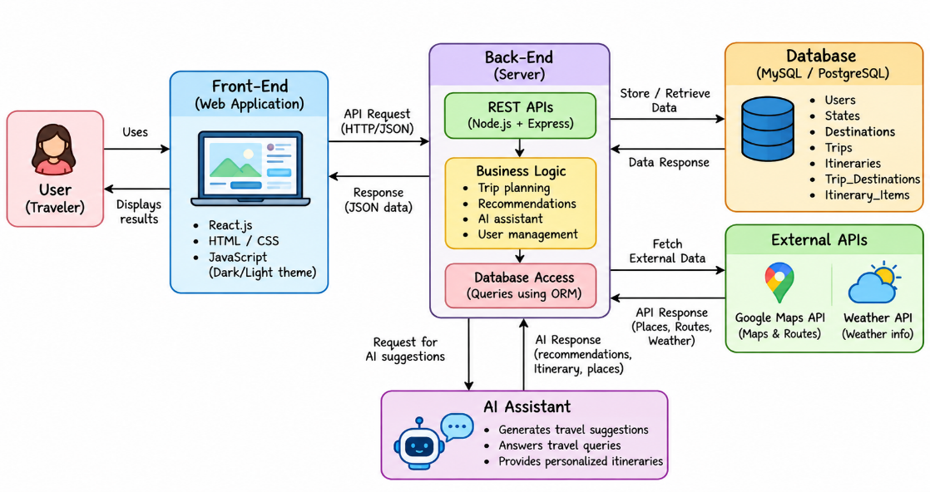
4.2 Description of Each Layer
The architecture of the Tourist Guide application is organized into multiple interconnected layers, with each layer responsible for a specific set of functions. This layered architecture helps separate the user interface, application logic, mapping services, local storage, artificial intelligence services, and external services. Such separation improves the organization, maintainability, and scalability of the application.
4.2.1 User Layer
The User Layer represents the traveller who directly interacts with the Tourist Guide application. Through the mobile interface, the user can access the major travel assistance features provided by the system. These include exploring digital maps, searching for destinations and places of interest, viewing points of interest (POIs), generating personalized travel itineraries, accessing emergency information, opening external booking services, and maintaining a personal Trip Journal.
The user layer acts as the starting point for most interactions within the system. User requirements and selections are passed to the appropriate application components, which process the request and return the required information through the Android interface.
4.2.2 Application Layer
The Application Layer represents the main Android application and acts as the central coordination layer of the system. It manages communication between the user interface and the underlying services and resources. The application layer is responsible for processing user input, controlling navigation between different screens, selecting the appropriate features, presenting information, and coordinating local and external operations.
It also manages communication with the Room Database, Mapbox services, and external APIs. When an online service is required, the application layer initiates the appropriate API request through the networking component. It also handles errors and unexpected situations so that users can receive appropriate feedback instead of encountering application failures.
4.2.3 Mapping Layer
The Mapping Layer is responsible for providing geographical and navigation-related functionality. It uses the Mapbox SDK to display interactive maps and visualize locations within the application. Users can interact with the map to explore destinations and geographical areas relevant to their travel requirements.
The layer also incorporates Mapbox Offline functionality to support the offline-first nature of the application. Required map resources can be downloaded while internet connectivity is available and subsequently accessed from the device when the user is offline. The mapping layer can therefore support map visualization and relevant POI interactions while reducing the application's dependency on continuous network connectivity.
4.2.4 Local Data Layer
The Local Data Layer is implemented using Room Database and is responsible for storing information directly on the user's Android device. Local persistence is particularly important for an offline-first application because essential information should remain accessible even when an internet connection is unavailable.
The layer can be used to maintain information such as Trip Journal entries, saved places, user notes, emergency-related information, locally available travel information, and other application data required during offline operation. The local data layer allows the application to retrieve and manage this information without depending on an external server for every operation.
4.2.5 AI Service Layer
The AI Service Layer provides the intelligent itinerary-generation functionality of the Tourist Guide application. It uses an LLM API to process travel requirements provided by the user and generate a personalized itinerary.
When a user requests AI-based assistance, the application collects relevant requirements such as destination, available travel time, interests, and preferred activities. These requirements are transmitted to the LLM service through the network layer. The generated itinerary is then returned to the application and presented to the user through the Android interface. Since this service depends on an external language model, an active internet connection is generally required for generating new AI responses.
4.2.6 External Service Layer
The External Service Layer represents services that are accessed outside the core Android application. These services may include external travel information APIs, booking platforms, and other online services required by specific application features.
For booking functionality, the Tourist Guide application may provide links that direct users to external booking platforms rather than processing financial transactions or completing reservations internally. This approach allows the application to act as a travel assistance and discovery platform while allowing specialized external services to handle booking transactions.
4.3 Offline-First Architecture
The offline-first architecture is one of the most important characteristics of the Tourist Guide application. Unlike a traditional online-first application, which depends heavily on remote servers and continuous internet connectivity, an offline-first system attempts to maintain important functionality through locally available resources.
This approach is particularly useful for travellers because network connectivity cannot always be guaranteed. Users may enter areas with weak signals, experience temporary network interruptions, or travel to locations where mobile connectivity is limited. The Tourist Guide application therefore separates its functionality into offline-oriented and online-dependent components.
Offline-oriented functionality includes previously downloaded city maps, locally stored emergency information, Trip Journal entries, saved travel information, and other data maintained through local storage. These resources can continue to be accessed from the device without requiring a continuous internet connection.
Online functionality includes services that depend on external systems, such as AI itinerary generation through the LLM API, external booking services, and other features that require fresh information from online sources. When connectivity is available, these services can be accessed normally through the application's networking layer.
This separation allows the Tourist Guide application to maintain useful functionality even when the user is temporarily disconnected from the internet. The architecture therefore combines local availability with online intelligence, providing a more resilient travel assistance experience.
4.4 Data Flow
The Tourist Guide application follows different data flows depending on the feature selected by the user. Each feature communicates with the appropriate system component while maintaining the overall layered architecture.
4.4.1 Offline Map Flow
For offline map functionality, the user first selects a city or geographical region that is required for travel. The application identifies the corresponding map resources and downloads them while an internet connection is available. The downloaded resources are stored locally and can subsequently be used to display the required map when the user is offline.
User → Select City → Download Map → Local Map Storage → Offline Map Display
4.4.2 POI Flow
The Point of Interest (POI) flow begins when the user accesses the POI Explorer and searches for a particular category or destination. The application processes the user's selection and retrieves the available POI information from the appropriate local or online source. The results are then presented to the user through the application interface.
User → POI Explorer → Search/Select Category → Retrieve POI Information → Display Results
4.4.3 AI Itinerary Flow
The AI itinerary flow begins when the user provides travel requirements such as destination, available time, interests, and preferred activities. The Android application sends these requirements through Retrofit to the LLM API. The language model processes the request and generates an itinerary, which is returned to the application and displayed through the Android user interface.
User → Enter Preferences → Retrofit → LLM API → Generated Itinerary → Android UI
4.4.4 Trip Journal Flow
The Trip Journal allows users to record information about their travel experiences. When the user adds a visited place, note, or other journal information, the application processes the entry and stores it in the Room Database. The stored information can later be retrieved and displayed through the Trip Journal screen, including when the device is offline.
User → Add Visited Place/Note → Room Database → Stored Journal Entry → Journal Screen
4.4.5 Emergency Information Flow
The Emergency Information flow is designed to provide users with important emergency-related information through the application. When the user opens the Emergency section, the application retrieves the relevant locally stored information and presents it through the user interface. Maintaining this information locally helps ensure that important emergency details remain accessible even when network connectivity is unavailable.
User → Emergency Section → Local Stored Information → Display Emergency Details
4.5 Deployment Architecture
The primary deployment target of the Tourist Guide application is an Android smartphone or compatible Android device. After development and testing, the application can be compiled and packaged into an Android application package for installation on supported devices.
The development-to-deployment process begins with the application source code written using Kotlin and managed through Android Studio. The project is built using the Android build system, after which the application is tested using an Android emulator and/or a physical Android device. Once the application has been successfully tested, an installable application package can be generated and deployed to the target Android device.
The overall deployment process can be represented as:
Source Code → Android Studio Build → Application Testing → APK Generation → Android Device
During operation, locally available components such as the Room Database and downloaded offline map resources can function directly on the Android device. Online components, including the LLM API and external booking services, require appropriate API configuration and an active network connection when their services are requested.
The deployment architecture therefore supports both local device-based functionality and cloud-based services, allowing the application to provide offline travel assistance while still accessing advanced online capabilities when connectivity is available.
4.6 Architecture Diagram Placement
The system architecture diagram should be included in this section to provide a visual representation of the relationships between the major components of the Tourist Guide application. The diagram should illustrate how the tourist interacts with the Android application and how the application communicates with the Mapbox SDK, Mapbox Offline, Room Database, LLM API, and external services.
The diagram should also demonstrate the major outputs of the system, including interactive maps, POI information, personalized itineraries, emergency information, booking links, and Trip Journal data. This visual representation complements the textual description of the architecture and provides a clear understanding of the overall data flow and component interaction.
The architecture diagram should therefore clearly represent the flow from the user layer through the Android application and supporting service layers to the final travel assistance features, while also highlighting the distinction between offline resources and online services.

CHAPTER – 5 DESIGN
5.1 System Design
The system design describes the overall structure and organization of the Tourist Guide application before and during the implementation phase. It provides a bridge between the identified system requirements and their practical implementation by defining the major application components, data structures, user interfaces, and functional workflows. The design focuses on creating an intelligent and offline-first travel assistance system in which important travel information remains accessible even when continuous internet connectivity is not available.
The Tourist Guide application is organized around six major user-facing capabilities: Offline Map Packs, POI Explorer, AI Itinerary Chatbot, Emergency Information, Booking Links, and Trip Journal. Each module addresses a specific travel requirement while working together as part of the overall application. These modules are supported by local data persistence through the Room Database, mapping functionality through Mapbox, network communication through Retrofit, and intelligent itinerary generation through the LLM API.
The system design also emphasizes simplicity and accessibility because the application is intended to be used in real travel situations. Users should be able to move between major features easily, access important information quickly, and continue using locally available functionality when network connectivity is unavailable.
5.2 ER Diagram / Database Schema
The Room Database forms the local data storage component of the Tourist Guide application. It is responsible for maintaining structured information that needs to remain available on the Android device. The database design should correspond to the entities and relationships implemented in the final version of the application.
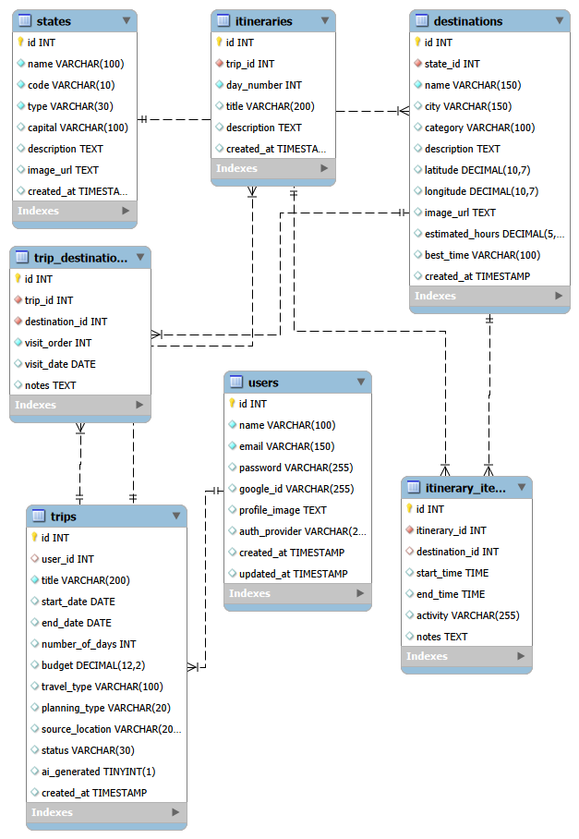
Depending on the final implementation, the database can contain logical entities such as user preferences, trips, journal entries, saved places, points of interest, emergency information, and offline map information. These entities can be organized using appropriate primary keys, attributes, and relationships to ensure that information can be stored and retrieved efficiently.
For example, a Trip can be associated with multiple Journal Entries, allowing users to maintain several records for a single travel experience. A journal entry may contain information such as the visited place, date of the visit, travel notes, personal memories, and other additional details supported by the application. Similarly, saved places and POI information can be associated with relevant travel or user records depending on the final database implementation.
The Room Database supports standard operations such as inserting new records, retrieving stored information, updating existing records, and deleting records when required. By storing important information locally, the database contributes to the offline-first architecture of the application and reduces dependency on continuous communication with remote servers.
[INSERT YOUR FINAL ROOM DATABASE / ER DIAGRAM HERE]
5.3 User Interface Design
The user interface of the Tourist Guide application is designed to provide simple and convenient access to travel-related functions. Since users may interact with the application while walking, travelling, or exploring unfamiliar locations, the interface should avoid unnecessary complexity and present important information in a clear and understandable manner.
The Home Screen acts as the main entry point to the application and provides access to the major modules. From the home screen, users can navigate to Maps, POI Explorer, AI Itinerary, Emergency Information, Bookings, and Trip Journal. Maintaining a consistent design across these sections helps users understand the application structure and reduces the learning effort required to access different features.
The navigation structure can be represented as:
Home → Maps
Home → POI Explorer
Home → AI Itinerary
Home → Emergency
Home → Bookings
Home → Trip Journal
The interface should maintain consistency in elements such as navigation controls, buttons, icons, typography, colors, and information presentation. The design should also prioritize important information and minimize the number of steps required to access frequently used travel functions.
5.4 Offline Map Design
The Offline Map module is designed to allow travellers to prepare geographical resources before beginning their journey. Since internet connectivity may not always be available during travel, the application provides a mechanism for downloading the required map resources while the user has an active internet connection.
The user can select the required city or geographical region and identify the map area that needs to be available during the trip. The selected map resources are then downloaded and stored for offline use. Once the resources have been successfully downloaded, the user can access the map even when the device has limited or no internet connectivity.
The general workflow of the offline map module is:
Select City/Region → Select Map Area → Download Map Resources → Store Locally → Open Map Offline → Use Available Map Information
This design reduces dependence on continuous network connectivity and allows users to prepare their travel maps in advance. The functionality is particularly useful when travelling through areas with weak or unreliable network coverage.
5.5 POI Design
The Point of Interest (POI) Explorer is designed to help users discover and explore useful locations within a destination. The module organizes locations into meaningful categories so that users can quickly identify places relevant to their travel requirements.
The categories considered in the project include tourist attractions, restaurants, hotels, hospitals, ATMs, and transportation facilities. These categories allow the application to support both recreational and essential travel requirements. For example, a traveller looking for places to visit can explore tourist attractions, while a user requiring essential services can access hospitals, ATMs, or transportation facilities.
The POI module allows the user to select a category and explore the available locations. Where supported by the implementation, the selected POIs can also be associated with the map interface so that users can understand their geographical position. The design therefore combines location discovery with map-based visualization, helping users distinguish between general attractions and essential services.
5.6 AI Itinerary Design
The AI Itinerary module is designed as a conversational travel-planning interface. It allows users to provide their travel requirements and receive a personalized itinerary generated through the integrated LLM API. This approach provides greater flexibility than a fixed itinerary system because the generated plan can be based on the individual requirements supplied by the user.
The user may provide information such as the destination, available travel duration, interests, preferred activities, and other relevant preferences. The application validates the required input and sends the appropriate information to the LLM API through the networking layer. The language model processes the request and generates an itinerary, which is then returned to the Android application and displayed to the user.
The conceptual workflow of the AI itinerary module is:
User Input → Input Validation → API Request → LLM Processing → Generated Response → Display in Android Application
The application should also account for situations in which the network is unavailable, the API request fails, or an unexpected response is received. Appropriate error handling and user feedback should be provided so that the application remains understandable and usable when the AI service cannot be accessed.
5.7 Emergency Information Design
The Emergency Information module is designed to provide users with important information that may be required during unexpected situations while travelling. Since emergencies can occur in locations where internet connectivity is limited, the design gives importance to making essential information available through local storage whenever possible.
The emergency section can provide information such as emergency contact details, essential services, nearby hospitals, and other important travel-related information supported by the final implementation. The information should be presented in a simple and easily accessible format so that users can locate the required details quickly.
Where appropriate, emergency information can be stored locally through the Room Database. This allows the information to remain accessible even when the device is temporarily offline. The design therefore supports the overall objective of providing reliable access to essential travel information under different connectivity conditions.
5.8 Trip Journal Design
The Trip Journal module provides users with a personal space for recording and maintaining information about their travel experiences. It allows travellers to document places they have visited, important dates, personal notes, memories, and other information supported by the application.
When a user creates a journal entry, the information is processed by the application and stored locally using the Room Database. Previously stored entries can subsequently be retrieved and displayed through the Trip Journal interface. Since the data is maintained locally, users can access their journal entries without requiring a continuous internet connection.
The Trip Journal therefore serves both as a personal travel record and as another example of the application's offline-first design. It allows users to preserve their travel experiences directly on the device while keeping the information available for later viewing and reference.

CHAPTER – 6 IMPLEMENTATION
6.1 Module-Wise Implementation
The Tourist Guide application is implemented as a collection of interconnected modules, with each module responsible for a specific aspect of the overall travel assistance system. The modular approach allows individual components to be developed, tested, and maintained independently while still working together as a unified application. The major modules of the system include the Map Module, POI Explorer, AI Itinerary, Emergency Information, Booking Links, Trip Journal, Local Storage, and Network Communication modules.
Each module communicates with the appropriate application services depending on the type of functionality being performed. Local operations are handled using resources available on the Android device, while features requiring external information communicate with online services through the networking layer. This modular structure also supports the offline-first design of the application by clearly separating locally available functionality from network-dependent functionality.
6.2 Offline Map Implementation
The Offline Map Module is implemented using the Mapbox SDK and Mapbox Offline functionality. The purpose of this module is to provide users with map information even when continuous internet connectivity is unavailable. The application allows users to identify the required city or geographical region and download the relevant map resources while an internet connection is available.
Once the required resources have been downloaded, they can be accessed locally on the Android device. This allows users to view the previously downloaded map information when travelling through areas with poor or unavailable network connectivity. The module therefore reduces the application's dependency on continuous internet access and supports the overall offline-first architecture.
During the download process, the application should provide appropriate feedback to the user, such as download progress, successful completion, or failure notifications. Situations such as interrupted downloads, insufficient device storage, or unavailable network connectivity should also be handled appropriately.

6.3 POI Explorer Implementation
The POI Explorer Module is implemented to help users discover useful locations within a destination. The application organizes points of interest into meaningful categories, allowing travellers to find locations according to their requirements. Categories may include tourist attractions, restaurants, hotels, hospitals, ATMs, and transportation facilities.
A typical interaction begins when the user opens the POI Explorer and selects a category. The application then allows the user to search or browse the available locations. After selecting a particular location, relevant information can be displayed through the application interface. Where supported by the implementation, the selected POI can also be associated with the map interface to provide geographical context.
The exact source and retrieval mechanism for POI information depend on the final implementation of the application. The module is designed to make the discovery of both recreational destinations and essential services more convenient for travellers.
6.4 AI Itinerary Chatbot Implementation
The AI Itinerary Chatbot is implemented using an LLM API to provide personalized travel-planning assistance. The module allows users to enter their travel requirements and preferences, which are then processed to generate a suitable itinerary.
The application first collects relevant information from the user, such as the destination, available travel duration, interests, and preferred activities. This information is prepared as an API request and passed through the Retrofit networking layer to the external LLM service. The LLM processes the request and returns a generated response, which is then handled by the application and presented to the user as an itinerary.
The overall implementation flow can be represented as:
User Input → Travel Preferences → Request Preparation → Retrofit → LLM API → Generated Response → Itinerary Display
Since the AI service is accessed through an external API, the module depends on network connectivity when a new itinerary is requested. The application should therefore handle situations such as network failures, invalid requests, unavailable services, or unsuccessful API responses and provide appropriate feedback to the user.
6.5 Emergency Information Implementation
The Emergency Information Module is designed to provide users with important information that may be required during unexpected situations while travelling. Since emergency situations may occur in locations where network connectivity is limited, information that needs to remain available during offline operation should be stored locally on the device whenever possible.
The module presents emergency-related information in a clear and accessible format so that users can quickly identify the required service or information. Depending on the final implementation, the module may include emergency contacts, hospitals, essential services, and other important travel information.
Local storage of essential emergency information improves accessibility and supports the application's offline-first design. This ensures that important information does not necessarily depend on a live network connection.
6.6 Booking Links Implementation
The Booking Links Module provides users with access to external booking services for travel-related requirements. Instead of implementing separate booking and payment systems within the Tourist Guide application, the system can provide links that redirect users to appropriate external booking platforms.
When the user selects a booking option, the application can open the corresponding external service through the available link. The external platform can then handle the actual booking process and any associated transaction requirements.
This approach reduces the complexity of implementing and maintaining multiple booking systems within the application while still providing users with convenient access to travel-related booking services from a centralized travel assistance interface.
6.7 Trip Journal Implementation
The Trip Journal Module provides users with a personal space for recording and maintaining their travel experiences. Journal information is stored locally using the Room Database, allowing users to access their records without requiring continuous internet connectivity.
When a user creates a journal entry, the application collects the relevant information and stores it in the local database. Previously stored entries can be retrieved and displayed through the Trip Journal interface. Depending on the final implementation, users can create, view, edit, and delete their journal entries.
The local storage approach ensures that personal travel records remain available on the device and contributes to the offline-first functionality of the overall system.
6.8 Local Travel Information
The application can maintain important travel-related information locally so that it remains accessible during offline operation. This is an important part of the offline-first design because travellers may not always have access to a reliable internet connection.
Locally stored information can be organized in a structured format using the Room Database, allowing the application to retrieve relevant information efficiently. Depending on the final implementation, this may include saved places, emergency information, Trip Journal records, user preferences, and other travel information required by the application.
By maintaining selected information locally, the system reduces unnecessary external requests and improves the availability of important functionality during offline use.
6.9 Front-End Logic
The Front-End Logic coordinates user interaction with the different modules of the Tourist Guide application. When a user selects a particular feature, the application determines how the request should be processed based on whether the required information is available locally or needs to be obtained from an external service.
For example, opening a previously stored Trip Journal entry can be handled entirely on the device using the Room Database. Similarly, viewing a previously downloaded map can be performed locally through the Mapbox Offline resources, and accessing stored emergency information does not necessarily require an internet connection. In contrast, generating a new AI itinerary generally requires communication with the external LLM API.
This separation between local and online operations is an important aspect of maintaining the offline-first behaviour of the application. It allows the application to continue providing useful functionality even when network connectivity is unavailable.
6.10 API Integration
Retrofit is used to manage communication between the Android application and external APIs. The API integration layer provides a structured mechanism for defining endpoints, preparing requests, receiving responses, and handling communication-related errors.
The implementation of an API-based service generally involves defining the API endpoint, creating appropriate request and response models, configuring the network client, executing the request, processing the response, and handling possible errors. In the Tourist Guide application, the LLM API represents the primary intelligent external service identified in the project.
When external booking services are used, the application may provide direct links to those services rather than processing booking transactions internally. This allows the application to integrate external travel services while keeping the core application architecture relatively simple.
6.11 Authentication and Authorization
Authentication and authorization are included in the system design only when they form part of the final implementation. If user authentication is implemented, it can be used to provide controlled access to user-specific information and services. For example, authenticated users could access personal Trip Journal data or other information associated with their account.
If account-based authentication is not implemented in the current version of the Tourist Guide application, authentication and authorization do not form part of the current functional implementation. In such a case, user authentication can be considered a possible future enhancement for providing personalized accounts, synchronized travel records, and secure access to user-specific data.
6.12 Error Handling
Error handling is an important part of the implementation because the Tourist Guide application is designed to operate in environments where network availability, location services, and device resources may vary. The application should detect potential problems and provide understandable feedback rather than exposing technical errors directly to the user.
Possible errors include unavailable internet connectivity, API communication failures, invalid API responses, interrupted map downloads, insufficient device storage, unavailable location services, and invalid user input. Each situation should be handled according to its nature. For example, when an online service is unavailable, the application can inform the user that the feature requires an internet connection, while locally stored information can continue to be accessed normally.
Appropriate error handling improves the reliability and usability of the application. It also supports the offline-first design by ensuring that temporary connectivity problems do not unnecessarily affect features that can operate using locally available resources.

CHAPTER 7- FEATURES
7.1 List of Main Features
The Tourist Guide application is designed as an integrated travel assistance system that combines mapping, destination discovery, artificial intelligence, emergency assistance, booking access, and personal travel record management within a single Android application. The major features of the system include Offline Map Packs, POI Explorer, AI Itinerary Chatbot, Emergency Information, Booking Links, Trip Journal, and Locally Stored Travel Information.
These features are designed to complement one another and provide users with the essential tools required before and during a journey. The combination of locally available resources and online services allows the application to provide useful functionality while also reducing its dependence on continuous internet connectivity.
7.2 Offline Map Packs
Offline Map Packs are one of the primary features of the Tourist Guide application. The feature allows users to download map information for a required city or geographical region before beginning their journey. The downloaded resources are stored on the device and can subsequently be accessed through the Mapbox-based mapping interface.
Once a map pack has been downloaded successfully, users can access the available map information without requiring continuous internet connectivity. This functionality is particularly useful when travelling through destinations where mobile network coverage is weak, unstable, or temporarily unavailable.
The offline map capability therefore supports the application's overall offline-first approach by allowing travellers to prepare essential geographical resources in advance and use them when required during their journey.
7.3 POI Explorer
The Point of Interest (POI) Explorer enables users to discover and explore useful locations within their destination. The feature organizes locations into different categories so that travellers can quickly identify places according to their requirements.
The categories considered in the project include tourist attractions, restaurants, hotels, hospitals, ATMs, and transportation facilities. By combining tourism-related destinations with essential services, the POI Explorer can support both recreational activities and practical travel requirements.
The feature provides users with a convenient way to discover places without having to search through multiple unrelated sources. When supported by the application, POI information can also be associated with the map interface to provide geographical context for the selected location.
7.4 AI Itinerary Chatbot
The AI Itinerary Chatbot provides personalized travel-planning assistance using an integrated LLM API. Instead of requiring users to manually organize every part of their travel schedule, the chatbot allows them to communicate their travel requirements through a conversational interface.
Users can provide information such as their destination, available travel time, interests, and preferred activities. This information is processed by the LLM service, which generates a suitable itinerary based on the requirements provided by the user. The resulting itinerary is then presented through the Android application.
The AI itinerary feature can reduce the manual effort involved in organizing a travel schedule and provide a more personalized planning experience. However, the generated itinerary is intended to serve as travel-planning assistance, and the final travel decisions remain with the user.
7.5 Emergency Information
The Emergency Information module provides users with quick access to important emergency contacts and essential service information. Since unexpected situations can occur during travel, this information is designed to be easily accessible through the application.
An important characteristic of this feature is the ability to maintain relevant information locally on the device. When essential emergency information is stored locally, users can access it even when internet connectivity is unavailable. This is particularly valuable in situations where obtaining information from an online service may not be possible.
The emergency section should therefore be presented prominently and organized clearly so that users can locate the required information quickly when needed.
7.6 Booking Links
The Booking Links feature provides users with convenient access to external travel booking services. Instead of implementing complete booking and payment infrastructure within the Tourist Guide application, the system can provide appropriate links that redirect users to external booking platforms.
Through this approach, users can identify the relevant booking option within the application and then continue the booking process through the selected external service. The external platform can handle the actual reservation, payment, and other transaction-related operations.
This design allows the Tourist Guide application to function as a centralized travel assistance platform while avoiding the additional complexity of implementing and maintaining multiple independent booking systems internally.
7.7 Trip Journal
The Trip Journal provides users with a personal space for recording and preserving their travel experiences. Users can maintain notes about places they have visited, important dates, personal memories, and other travel-related information supported by the application.
The journal records are stored locally using the Room Database, allowing users to access their saved information without requiring continuous internet connectivity. This also ensures that personal travel records remain available on the device during offline usage.
The Trip Journal therefore serves as both a practical record-keeping feature and a personal travel diary, allowing users to preserve their experiences and revisit them later.
7.8 Local Travel Information
The application can retain important travel-related information locally to support its offline-first architecture. Rather than retrieving every piece of information from an external service whenever it is required, selected information can be stored directly on the user's device.
Local information may include saved places, emergency details, Trip Journal records, user preferences, downloaded map resources, and other information supported by the final implementation. Organizing this information through local storage allows the application to retrieve it efficiently and reduces unnecessary dependency on network communication.
This approach contributes to the overall reliability of the system, particularly when users are travelling through areas with limited or unavailable connectivity.
7.9 Expected User Experience
The expected user experience of the Tourist Guide application is centered around simplicity, accessibility, and convenient access to travel information. The application is designed to bring several commonly required travel functions together within a single interface instead of requiring users to depend on multiple unrelated applications.
A typical traveller should be able to open the application, access a map, explore destinations and useful places, generate a personalized itinerary, view emergency information, access relevant booking services, and record their travel experiences through the Trip Journal. The application should provide clear navigation between these functions while maintaining a consistent interface throughout the system.
The combination of offline maps, locally stored information, POI discovery, AI-based itinerary generation, emergency assistance, booking access, and personal travel records is intended to provide a unified travel assistance experience. The offline-first approach further ensures that important locally available functionality can continue to be used even when continuous internet connectivity is not available.

CHAPTER – 8 TESTING
8.1 Introduction to Testing
Testing is an essential phase of the software development lifecycle and is performed to verify that the Tourist Guide application behaves according to the specified requirements. The primary objective of testing is to identify functional errors, integration problems, data-handling issues, and connectivity-related problems before the application is considered ready for deployment.
Since the Tourist Guide application follows an offline-first architecture, testing is not limited to normal online operation. The application must also be evaluated under offline and limited-connectivity conditions to determine whether locally stored information and downloaded resources remain accessible. Testing therefore covers the application's user interface, individual functionality, database operations, API communication, module integration, offline behaviour, error handling, and mapping functionality.
8.2 Functional Testing
Functional testing is performed to verify that each feature of the Tourist Guide application performs its intended operation. The testing process begins with basic application operations such as launching the application and navigating between different screens, followed by testing individual travel assistance features.
The Maps module is tested by opening the map interface, selecting an appropriate geographical area, downloading the required map resources, and subsequently opening the downloaded map. The POI Explorer is tested by opening the module, selecting different categories, and verifying that the corresponding location information is displayed correctly. The AI Itinerary module is tested by submitting valid travel requirements and verifying that the request is processed and the generated response is presented through the application.
Other functional tests include opening the Emergency Information section, accessing external Booking Links, creating new Trip Journal entries, and retrieving previously saved journal records. These tests help verify that the major features of the application perform according to their intended functionality.
8.3 API Testing
API testing is performed to verify communication between the Android application and applicable external services. The LLM API is particularly important because it is responsible for processing user travel requirements and generating personalized itineraries.
Before integrating an API into the Android application, tools such as Postman can be used, where applicable, to inspect the behaviour of API endpoints and verify the request and response structure. Testing should confirm that the correct endpoint is being accessed, the request contains the required parameters, and the returned response follows the expected format.
API testing should also consider unsuccessful situations, including invalid requests, missing parameters, incorrect responses, network failures, and unavailable services. Appropriate handling of these situations ensures that the application does not fail unexpectedly when an external service cannot be reached.

8.4 Integration Testing
Integration testing verifies whether the individual modules of the Tourist Guide application work correctly when they are combined. Since the application contains multiple interconnected components, successful operation of each individual module does not necessarily guarantee that the complete system will function correctly.
For example, the integration between Mapbox and local storage is tested by verifying that downloaded map resources can be accessed correctly when network connectivity is unavailable. The integration between Retrofit and the LLM API is tested by checking whether user requirements are correctly transmitted to the external service and whether the returned response is processed and displayed properly.
Similarly, the integration between the Trip Journal and Room Database is tested by creating journal entries through the user interface and verifying that the information is correctly stored and retrieved. The connection between the user interface and database is also tested to ensure that modifications made through the application are correctly reflected in the locally stored data.
8.5 Offline Testing
Offline testing is particularly important for the Tourist Guide application because offline accessibility is one of the main objectives of the system. The application should be tested with internet connectivity disabled to determine which features continue to operate using locally stored resources and which features appropriately indicate the need for network access.
For example, when internet connectivity is disabled after a map pack has been downloaded, the downloaded map should remain accessible. Similarly, locally stored emergency information and Trip Journal entries should remain available because they are maintained on the device.
On the other hand, if a user attempts to generate a new AI itinerary while offline, the application should clearly indicate that network access is required for communicating with the LLM API. Stored travel information should continue to be displayed without requiring an external request.
Offline Test | Expected Result
Open a previously downloaded map without internet | Downloaded map remains accessible
Open Emergency Information while offline | Locally stored emergency information is displayed
Open Trip Journal while offline | Previously saved journal entries remain accessible
Request a new AI itinerary while offline | Application indicates that network access is required
Open locally stored travel information | Stored information is displayed successfully
This testing ensures that the offline-first behaviour of the application is consistent with the intended system design.
8.6 Tools Used for Testing
Several development and testing tools can be used during the validation of the Tourist Guide application. Android Studio provides the primary environment for building, running, debugging, and testing the Android application. The Android Emulator can be used to simulate different Android devices and operating conditions, while a physical Android device can be used to validate the application's behaviour under real-world conditions.
Logcat is useful for monitoring application execution and identifying runtime errors, warnings, and debugging information. Postman can be used where applicable to test API requests and responses before or during API integration. Git and GitHub support version tracking and allow changes made during testing and debugging to be maintained systematically. In addition to these tools, manual functional testing is used to verify the behaviour of the application's major features from the user's perspective.
8.7 Sample Test Cases
A set of test cases can be defined to systematically verify the major functions of the Tourist Guide application. Each test case specifies an operation to be performed and the expected result. The following test cases provide a structured basis for validating the application.
Test Case ID | Test Description | Expected Result
TC01 | Launch the application | Application opens successfully
TC02 | Open Maps | Map interface is displayed
TC03 | Download a map pack | Selected map data is downloaded successfully
TC04 | Open downloaded map offline | Downloaded map remains accessible
TC05 | Open POI Explorer | POI categories are displayed
TC06 | Select an attraction category | Relevant POI information is displayed
TC07 | Request an AI itinerary | Request is processed when network connectivity is available
TC08 | Open Emergency Information offline | Stored emergency information is displayed
TC09 | Open a booking link | Appropriate external booking service is opened
TC10 | Add a Trip Journal entry | Journal entry is saved successfully
TC11 | Reopen Trip Journal | Previously saved entry is displayed
TC12 | Disable network during an API request | Appropriate error or information message is displayed
These test cases provide coverage of the major functional, offline, database, networking, and integration aspects of the application. Additional test cases can be added depending on the final implementation and the specific features included in the deployed version.
8.8 Test Results
The final testing stage should document the actual results obtained from executing the defined test cases. Each test case should be marked according to its observed behaviour, such as passed, failed, or requiring further investigation. Any issues identified during testing should also be documented along with the corrective actions performed.
The final project report should include screenshots that provide evidence of the testing process. These may include screenshots of the Android Studio application output, emulator or physical-device screens, map and offline-map functionality, POI Explorer, AI itinerary responses, API testing results, Emergency Information, Trip Journal operations, and database records.
The completed testing results demonstrate whether the implemented Tourist Guide application satisfies its functional requirements and whether its offline-first behaviour operates as intended under different connectivity conditions.

CHAPTER – 9 DEPLOYMENT

9.1 Steps to Deploy the Application
The Tourist Guide application is developed as an Android mobile application, and its deployment involves building the application, configuring the required services, testing the final build, and installing it on a compatible Android device. Before deployment, the complete project should be opened in Android Studio and checked to ensure that all required dependencies, libraries, SDK components, and project configurations are correctly available.
The deployment process begins by verifying the project configuration and required dependencies. The necessary Android SDK components should be installed and configured, followed by the configuration of external services such as Mapbox and the LLM API. Required permissions, including internet and location permissions where applicable, should also be configured correctly. After the configuration is completed, the application is built and tested using an emulator and, preferably, a physical Android device. Once the application has been successfully validated, an Android application package can be generated and installed on the target device for final verification.
The overall deployment process can be represented as:
Android Studio Project → Dependency and SDK Configuration → API Configuration → Build → Testing → APK Generation → Android Device Installation → Final Verification
9.2 Environment Configuration
Before deploying the application, the required environment and external service configurations must be completed. Since the Tourist Guide application uses mapping, artificial intelligence, location-based services, and network communication, appropriate configuration is required for these components to operate correctly.
The environment configuration may include Mapbox configuration, LLM API configuration, internet permissions, location permissions, and other application-specific settings. The Mapbox configuration is required for map-related functionality, while the LLM API configuration is required for AI-based itinerary generation. Location permissions should be configured when the application requires access to the user's location for location-based functionality.
Security is also an important consideration during deployment. Sensitive API keys and credentials should not be hard-coded into publicly shared source code or repositories. Appropriate configuration and secure storage mechanisms should be used to protect confidential information and prevent unauthorized access to external services.
9.3 Hosting
The Tourist Guide application differs from a conventional web application because its primary deployment target is an Android device rather than a separately hosted website. The application is packaged as an Android application and installed directly on a compatible smartphone or other supported Android device.
Although the main application runs locally on the user's device, some of its functionality may depend on external services. For example, the LLM API requires communication with an external service when the user requests a new AI-generated itinerary. Similarly, external booking services may be accessed through links provided within the application. These services operate independently of the Android application and may require an active internet connection.
The application's local components, including Room Database and downloaded offline map resources, are maintained on the user's device and can support functionality without continuous communication with a remote server.
9.4 APK Generation
After the application has been successfully implemented and tested, an Android Application Package (APK) can be generated using Android Studio. The APK contains the application components required for installation and execution on a compatible Android device.
Before generating the final APK, the application should be tested to ensure that the major features operate correctly and that there are no critical build or runtime errors. Once the build is successfully completed, the generated APK can be transferred to a compatible Android device and installed for demonstration, evaluation, or further testing.
Although an emulator can be used during development, testing the final APK on an actual Android device is recommended whenever possible. Physical-device testing can provide additional validation of features such as GPS/location services, storage, map performance, permissions, and offline operation.
9.5 Post-Deployment Verification
After the application has been installed on the target Android device, a final verification process should be performed to confirm that the deployed version operates correctly. The application should first be launched to verify successful installation and startup. The major functional modules should then be tested individually to ensure that the deployment has not introduced any configuration or runtime issues.
The Map module should be checked to confirm that maps are displayed correctly and that previously downloaded map resources remain accessible in offline mode. The POI Explorer should be tested to verify that categories and relevant location information are displayed correctly. The AI Itinerary Chatbot should be tested with network connectivity to ensure that requests are successfully communicated to the LLM API and that generated responses are displayed correctly.
The Emergency Information section should be checked to confirm that important stored information remains accessible. Booking Links should be tested to verify that the appropriate external services can be opened. The Trip Journal should also be tested by creating and retrieving entries to confirm that local data persistence through Room Database is functioning correctly.
Particular attention should be given to offline operation, as it is one of the defining characteristics of the Tourist Guide application. Downloaded maps, locally stored travel information, emergency information, and Trip Journal records should remain accessible when internet connectivity is disabled. At the same time, features that require external services should provide appropriate information to the user when network connectivity is unavailable.
The final deployment verification therefore ensures that the application operates correctly not only under normal online conditions but also under the offline conditions for which the system has been specifically designed.

CHAPTER – 10 CHALLENGES & LIMITATIONS
10.1 Issues Faced During Development
The development of the Tourist Guide application involves several technical and design challenges because the system combines Android application development, offline mapping, local data storage, external APIs, and artificial intelligence within a single platform. Integrating these components requires careful coordination between local and online resources while maintaining a consistent user experience.
One of the major challenges is offline data management. Since the application follows an offline-first approach, it is necessary to determine which information should be stored locally and which information should be obtained from external services. Information that is essential during offline operation needs to remain available on the device, while dynamic information may need to be retrieved through network-based services. Designing this separation correctly is important for maintaining the expected behaviour of the application.
Another challenge is the management of offline map data. Map resources can require considerable device storage depending on the geographical area and level of detail selected by the user. Therefore, the application needs to manage downloaded map resources carefully and provide appropriate information to users regarding storage requirements and download operations.
Network dependency is another important consideration. Although the application is designed using an offline-first approach, certain functionality still depends on external services. For example, generating a new AI itinerary requires communication with the LLM API. Therefore, the application needs to distinguish between locally available features and network-dependent features and clearly inform users when an internet connection is required.
The integration of external APIs also introduces additional challenges. Different APIs may use different request structures, response formats, authentication mechanisms, and error-handling requirements. Processing these responses correctly and integrating them with the Android application can require additional development and testing.
Another challenge relates to AI-generated responses. The output of a language model can vary depending on the information provided by the user and the behaviour of the model. Therefore, generated itineraries should be treated as travel-planning assistance rather than guaranteed factual information. The application should present AI-generated information appropriately and users should verify important travel details when necessary.
The design of the Room Database also requires careful consideration. Local entities, relationships, and database operations must be structured appropriately so that information such as journal entries, saved places, emergency information, and other locally stored data can be retrieved efficiently.
Finally, Android device differences can affect application behaviour. Android devices may differ in screen size, hardware capabilities, available storage, Android version, GPS performance, and system resources. These differences can influence the application's appearance and performance, making testing across different devices or configurations an important part of development.
10.2 Solutions Applied
Several approaches are incorporated into the system design to address the challenges identified during development. One of the primary solutions is the use of Room Database for persistent local storage. Information that needs to remain accessible during offline operation can be maintained locally, reducing unnecessary dependence on external servers.
For geographical functionality, Mapbox Offline is used to support downloadable map resources. Users can prepare the required map areas before travelling and access the downloaded resources when internet connectivity is unavailable. This approach directly supports the offline-first objective of the application.
The application also incorporates network error handling to manage situations where an external service cannot be reached. Instead of allowing a network failure to cause unexpected application behaviour, the system can provide an understandable message informing the user that a particular service requires network connectivity or is temporarily unavailable.
A modular architecture is another important solution applied in the project. Separating the system into modules such as Maps, POI Explorer, AI Itinerary, Emergency Information, Booking Links, and Trip Journal makes individual components easier to develop, test, debug, and maintain. Changes to one module can also be managed with less impact on unrelated components.
For external communication, Retrofit provides a structured API abstraction layer. It simplifies the process of defining API requests, processing responses, and handling network communication without requiring extensive low-level networking code within the application.
Git and GitHub are used for version control and source-code management. They allow changes to the project to be tracked systematically, provide a history of development activities, and support collaboration and recovery of previous versions when necessary.
10.3 Current Limitations or Known Limitations
Although the Tourist Guide application is designed to provide offline-first travel assistance, several limitations remain in the current version. One important limitation is that the AI Itinerary Chatbot requires network access when generating a new response because the application communicates with an external LLM API. Therefore, a new AI-generated itinerary may not be available when the device is completely offline.
Similarly, offline map functionality requires prior downloading of the required map resources. If a user enters an area without connectivity and the required map data has not previously been downloaded, the application may not be able to provide the necessary offline map information.
Downloaded map resources can also consume a significant amount of device storage, particularly when large geographical areas or detailed map data are selected. Storage availability therefore becomes an important consideration when preparing offline map packs.
The Booking Links feature also depends on external booking services. The availability, content, performance, and behaviour of these services are outside the direct control of the Tourist Guide application. Changes made by an external service may therefore affect the corresponding booking functionality.
Another limitation concerns data freshness. Information stored locally may become outdated if it is not periodically updated. This is particularly relevant for information that can change over time, such as service availability, locations, contact information, or other travel-related details.
Location accuracy is also dependent on the capabilities of the user's device and environmental conditions. Factors such as GPS signal quality, indoor environments, network conditions, and surrounding structures can affect the accuracy and availability of location information.
External APIs may also experience temporary downtime, rate limitations, configuration errors, or network failures. Such conditions can affect features that depend on online services, even when the core Android application itself is functioning correctly.
Finally, AI-generated information may not always represent the latest local conditions. Generated itineraries should therefore be considered as planning assistance rather than authoritative travel information. Users should verify important details such as operating hours, availability, local restrictions, and other time-sensitive information before relying on them.
10.4 Known Improvement Areas
The Tourist Guide application can be further enhanced through several future improvements. One important area is improved offline synchronization, which could allow locally stored information to be updated more efficiently whenever connectivity becomes available. This would help maintain a balance between offline availability and information freshness.
The system could also be extended with a more comprehensive local travel database containing additional destinations, services, emergency information, and points of interest. Better management of downloaded map resources could further reduce storage requirements and provide users with greater control over which geographical areas are stored on their devices.
Future versions can include enhanced error handling and recovery mechanisms to provide more informative feedback when APIs, maps, location services, or network connections become unavailable. The POI Explorer can also be expanded with more detailed information, such as additional place descriptions, categories, and other relevant travel information supported by the available data sources.
The AI component can be improved through better prompt design and more structured itinerary generation. Future implementations may also incorporate additional contextual information to make generated travel plans more relevant to individual users while maintaining appropriate handling of uncertain or dynamically changing information.
Accessibility is another potential area for improvement. The application can be enhanced with clearer visual elements, improved text readability, accessible navigation, and other design considerations that make the system easier to use for a wider range of users.
Future versions may also provide multilingual support, allowing travellers to interact with the application and access travel information in multiple languages. More advanced travel recommendations could further enhance the system by considering factors such as available time, user interests, destination characteristics, and locally available travel information.
Overall, these improvements can help evolve the Tourist Guide application into a more comprehensive, accessible, and reliable intelligent offline-first travel assistance platform while maintaining its core focus on convenient travel information and reduced dependence on continuous internet connectivity.

CHAPTER – 11 FUTURE ENHANCEMENTS
11.1 Planned Features
The Tourist Guide application provides a foundation that can be further extended with additional intelligent, offline, and personalized travel features. Future development can focus on increasing the amount of information available without internet connectivity, improving the capabilities of the AI travel assistant, and providing a more personalized and accessible experience for different types of travellers.
One of the major areas of future development is advanced offline support. The current offline-first concept can be expanded beyond maps and emergency information by allowing additional destination details, transportation information, restaurant information, hotel details, and other useful travel resources to be cached locally. This would allow travellers to access a larger collection of information even when network connectivity is unavailable.
The AI Travel Assistant can also be developed into a more comprehensive conversational travel companion. Instead of only generating an itinerary, future versions could allow users to ask natural-language questions about their destination. For example, users could ask what places they can visit on a particular day, request recommendations near their current location, plan a one-day trip, find restaurants near a destination, modify an existing itinerary, or request activities based on their personal interests. This would make the AI component more interactive and useful throughout the entire travel experience.
Another important enhancement is multilingual support. The application could provide its user interface, POI information, emergency information, and AI-generated responses in multiple languages. This would make the application more accessible to travellers from different linguistic backgrounds and could improve usability in destinations where users may not be familiar with the local language.
Voice-based travel assistance could also be introduced in future versions. Users could communicate with the travel assistant using voice commands instead of typing their requirements. This could be particularly useful while walking, driving, or carrying luggage, where interacting with a touchscreen may be inconvenient.
The Trip Journal can be enhanced to provide a richer travel-recording experience. Future versions could allow users to associate photographs, location coordinates, dates, travel routes, categories, personal ratings, and other information with their journal entries. The application could also provide options to organize multiple trips separately and export selected travel records for personal use.
The POI Explorer could also become more personalized by considering user preferences and previous interactions. For example, a traveller interested in historical locations could receive more heritage-related recommendations, while a user interested in food could receive more restaurant-oriented suggestions. Such personalization could make destination discovery more relevant to individual users.
11.2 Possible Integrations
The Tourist Guide application can be expanded by integrating additional external travel-related services. Possible integrations include public transportation information, weather services, hotel services, restaurant services, travel advisory information, local tourism databases, and travel insurance services.
These integrations could provide users with more comprehensive travel information from a single application. For example, weather information could help users plan outdoor activities, while public transportation information could assist them in travelling between different destinations. The exact integrations would depend on the availability, reliability, access conditions, and technical requirements of the relevant APIs and services.
11.3 Improved Offline Synchronization
Future versions can implement a more advanced offline synchronization mechanism between locally stored information and online services. When the device becomes connected to the internet, the application could automatically synchronize selected information and refresh locally stored data.
Such synchronization would help maintain a balance between offline availability and information freshness. Users could continue using locally available information while offline, and the application could update selected resources when connectivity is restored. This approach could be particularly useful for POI information, travel details, and other data that may change over time.
11.4 Emergency Assistance Enhancements
The existing Emergency Information module can be extended with additional assistance capabilities. Future versions could incorporate features such as SOS functionality, location sharing, emergency service integration, nearby hospital navigation, and predefined emergency message templates.
For example, an SOS feature could allow a user to quickly initiate an emergency action, while location sharing could help communicate the user's approximate position to a selected contact. Nearby hospital navigation could combine emergency information with the mapping functionality of the application.
Because these features may involve sensitive location and personal information, future implementations would need to place particular emphasis on privacy, security, permissions, reliability, and appropriate user consent.
11.5 Augmented Reality
Augmented Reality (AR) could be explored as a future enhancement to improve destination discovery. Using the device camera, users could potentially view information about nearby attractions, landmarks, or other points of interest overlaid on their surroundings.
For example, when a traveller points the camera toward a landmark, the application could display relevant information about that location. AR functionality could therefore provide a more interactive way of exploring unfamiliar destinations and complement the existing map and POI features.
11.6 Wearable Device Integration
The Tourist Guide application could also be extended to support smartwatches and other wearable devices. Important travel information could be made available directly on a wearable device so that users do not always need to take out their smartphones.
Potential wearable features could include navigation instructions, itinerary reminders, emergency contacts, selected travel notifications, and other important information. This integration could provide a more convenient travel experience, particularly when users are walking or exploring a destination.
11.7 Personalization
Future versions of the application could introduce a more comprehensive personalization system. The application could maintain user preferences such as preferred attractions, travel interests, preferred activity types, typical travel duration, and saved destinations.
These preferences could be used to improve future itinerary generation and destination recommendations. For example, if a user frequently selects historical attractions, the system could consider this preference when generating future travel suggestions. Personalization could therefore make the application more relevant to individual travel habits while still allowing users to modify or control their preferences.
11.8 Security and Privacy Improvements
As the application becomes more feature-rich, security and privacy will become increasingly important. Future versions should continue improving the protection of locally stored and transmitted user information.
Potential improvements include secure local data storage, secure API communication, proper API key management, privacy controls, user-controlled data deletion, and improved permission management. The application should request only the permissions required for its functionality and provide users with appropriate control over their personal information and location-related data.
Security measures should also be considered when integrating external APIs and services so that sensitive credentials are not exposed through publicly accessible source code or application resources.
11.9 Overall Future Vision
The long-term vision of the Tourist Guide project is to develop a comprehensive intelligent travel assistant that combines offline navigation, destination discovery, personalized travel planning, emergency assistance, booking access, and travel journaling within a unified platform.
The project can gradually evolve from an offline-focused travel application into a broader intelligent travel companion by incorporating advanced AI assistance, multilingual interaction, voice-based communication, personalized recommendations, richer offline resources, AR-based exploration, wearable integration, and additional travel services.
Despite these future enhancements, the offline-first philosophy can remain a central characteristic of the system. By combining locally available information with intelligent online services, the application can aim to provide a flexible and reliable travel assistance experience across different connectivity conditions and travel scenarios.

CHAPTER – 12 CONCLUSION
12.1 Summary of the Project
The Tourist Guide – An Offline-First Intelligent Travel Assistance System was developed to address common challenges faced by travellers when accessing information and services in unfamiliar destinations. A major focus of the project is the problem of unreliable or unavailable internet connectivity, which can affect the usability of conventional travel applications that depend heavily on continuous online access.
To address this limitation, the Tourist Guide application follows an offline-first approach, combining locally available resources with online services. The system brings together offline maps, local travel information, emergency information, destination discovery, AI-based itinerary generation, external booking access, and a Trip Journal within a single Android application. This approach allows users to access important information locally while still benefiting from advanced online services whenever network connectivity is available.
The application is developed using Android and Kotlin as its primary platform and programming language. Mapbox SDK and Mapbox Offline are used to provide mapping and offline map functionality, while Room Database provides local data persistence. Retrofit is used for communication with external REST-based services, and an LLM API provides AI-powered itinerary generation. These technologies are integrated to create a unified travel assistance environment.
12.2 What Was Achieved
The project establishes the design and implementation of a mobile travel assistance system that brings several important travel functions together within a single application. The major capabilities include offline city map support, POI exploration, AI-based itinerary assistance, offline emergency information, external booking links, Trip Journal functionality, and local storage of important travel information.
The offline map capability addresses the dependency on continuous internet connectivity by allowing users to download relevant geographical information in advance. The POI Explorer assists travellers in discovering attractions as well as essential services such as restaurants, hotels, hospitals, ATMs, and transportation facilities.
The AI Itinerary Chatbot provides an intelligent approach to travel planning by allowing users to provide their preferences and requirements and receive a generated itinerary. Emergency information can be maintained locally so that important details remain accessible during offline conditions. Booking links provide convenient access to external travel services, while the Trip Journal allows users to maintain personal records of their travel experiences.
Together, these capabilities demonstrate how different travel-related functions can be integrated into a single Android-based platform rather than requiring users to depend on several unrelated applications.
12.3 Technical Achievements
From a technical perspective, the project demonstrates the integration of multiple areas of computer science and software development. The use of Kotlin and Android Studio provides practical experience in mobile application development, interface design, application lifecycle management, and Android project configuration.
The integration of Mapbox SDK and Mapbox Offline demonstrates the use of digital mapping technologies and the management of geographical resources for offline access. The implementation of Room Database provides experience in local persistence, structured data management, and database operations within an Android environment.
The use of Retrofit demonstrates REST-based API communication and integration with external services. The integration of an LLM API demonstrates how artificial intelligence can be incorporated into a mobile application to provide personalized travel-planning assistance. The use of Git and GitHub further provides experience in version control, source-code management, and systematic software development.
The combination of these technologies provides practical experience in developing a real-world application that integrates mobile computing, databases, digital mapping, networking, and artificial intelligence.
12.4 Project Significance
The primary significance of the project lies in its offline-first architecture. Travel applications should not assume that users will always have access to reliable and continuous internet connectivity. Travellers may encounter remote locations, poor network coverage, temporary connectivity failures, or situations where online services are unavailable.
By allowing users to download maps and maintain important information locally, the Tourist Guide application provides a more resilient travel assistance experience. Features such as downloaded maps, stored emergency information, Trip Journal records, and other locally available resources can continue to function without requiring constant communication with external servers.
At the same time, the project does not attempt to completely eliminate online services. Instead, it combines local and online capabilities according to the requirements of each feature. Locally stored resources support offline functionality, while network-dependent services such as new AI itinerary requests can be accessed when an internet connection is available. This combination provides a practical balance between offline reliability and online intelligence.
12.5 Skills Learned During Development
The development of the Tourist Guide application provides practical experience across several areas of software engineering and computer science. The project involves Android application development, Kotlin programming, user interface design, digital map integration, offline map management, local database management, REST API integration, AI and LLM integration, network error handling, software testing, version control, and application deployment.
In addition to technical skills, the project provides experience in converting a real-world problem into a structured software solution. It involves identifying user requirements, designing system architecture, selecting appropriate technologies, dividing the application into functional modules, implementing individual components, integrating those components, testing the complete system, and considering limitations and future improvements.
This development process provides practical exposure to the complete software development lifecycle rather than focusing only on individual programming concepts.
12.6 Final Conclusion
The Tourist Guide – An Offline-First Intelligent Travel Assistance System demonstrates how modern mobile technologies can be combined to address practical challenges in the tourism and travel domain. By integrating offline maps, POI exploration, AI-based itinerary planning, emergency information, booking links, local storage, and a Trip Journal, the application provides a unified environment for several common travel requirements.
The offline-first architecture is a central aspect of the project because it allows important resources to remain accessible even when continuous internet connectivity is not available. At the same time, the integration of online APIs and artificial intelligence enables the application to provide additional capabilities when network access is available.
The project also establishes a foundation for further development. Future versions can incorporate multilingual support, voice-based interaction, advanced personalization, improved offline synchronization, enhanced emergency assistance, augmented reality, wearable-device integration, and additional travel-service integrations.
Overall, the project demonstrates the practical application of mobile computing, database technology, digital mapping, API-based communication, and artificial intelligence to the real-world domain of tourism. It provides a foundation for developing a more comprehensive intelligent travel companion while maintaining its core objective of providing useful and accessible travel assistance across different connectivity conditions.

CHAPTER – 13 REFERENCES
13.1 References
The development of the Tourist Guide – An Offline-First Intelligent Travel Assistance System was supported by various official documentation sources, development tools, software libraries, APIs, and project-related materials. The primary references were selected to understand Android application development, Kotlin programming, offline map management, local database storage, API communication, artificial intelligence integration, and version control.
For Android application development, the Android Developers Documentation provided by Google was used as a major technical reference. It was useful for understanding Android application architecture, application components, user interface development, permissions, storage, lifecycle management, and other Android development practices. The Android documentation and the Build Your First Android App learning resources were also useful for understanding the standard process of developing and testing Android applications using Android Studio. Kotlin documentation was referred to for understanding the Kotlin programming language, language features, asynchronous programming, and coroutines used in Android development.
Android Studio Documentation was consulted for project creation, dependency management, application building, debugging, emulator configuration, APK generation, and deployment. Android Studio served as the primary integrated development environment for developing and testing the application.
For mapping and location-based functionality, Mapbox Documentation was used as an important reference. The Maps SDK for Android documentation provided information related to map integration, map display, location services, markers, and map interaction. Documentation related to Mapbox Offline functionality was also referred to for understanding the downloading, storage, and usage of map resources when an internet connection is unavailable. These resources were particularly relevant to the offline-first design of the Tourist Guide application.
For local data management, the Android Developers documentation for Room Database was consulted. The Room Persistence Library documentation helped in understanding entities, data access objects, database operations, local persistence, and the management of application data. Room was particularly relevant for storing information such as saved places, Trip Journal entries, local travel information, user preferences, and other data that should remain accessible without continuous internet connectivity.
For network communication and API integration, Retrofit documentation was referred to for understanding the implementation of type-safe HTTP communication in Android applications. The documentation provided guidance on creating API interfaces, sending requests, receiving responses, handling asynchronous operations, and managing communication between the Android application and external services. Retrofit was particularly useful for connecting the application with online services, including the selected LLM API used for itinerary generation.
For the artificial intelligence component, the official documentation of the selected Large Language Model (LLM) API was used to understand API authentication, request formats, response formats, prompt submission, error handling, and integration requirements. The documentation related to the selected AI service should be cited according to the exact API used in the final implementation. The AI component was integrated to support personalized itinerary generation based on user-provided travel requirements such as destination, duration, interests, and preferences.
For version control and collaborative development, the official Git Documentation and GitHub Documentation were consulted. These resources provided guidance on repository management, version control, commits, branches, remote repositories, project collaboration, and maintaining the source code of the application. GitHub was also used as a suitable platform for maintaining and managing the project's source code when applicable.
In addition to technical documentation, the Tourist Guide – An Offline-First Intelligent Travel Assistance System project presentation, design materials, architecture diagrams, testing materials, and other project documentation developed during the implementation were used as internal project references. Any sample project documentation provided as a reference for preparing the report format may also be acknowledged separately where appropriate.
13.2 Documentation and Tutorials
Official documentation was given preference throughout the development of the Tourist Guide application because it provides reliable and technically relevant information about the frameworks, SDKs, libraries, and APIs used in the project. Documentation was consulted whenever information was required regarding Android application development, Kotlin programming, Mapbox integration, offline maps, Room Database, Retrofit, API communication, and artificial intelligence services.
The final version of this report should include the exact URLs of the official documentation actually used during development, along with the corresponding access dates. This ensures that the references are traceable and that the report accurately identifies the technical resources consulted during the project.
Final Documentation URLs and Access Dates:
The exact URLs and access dates should be added here based on the technologies and APIs used in the final implementation.
13.3 Source Code Repository
The source code of the Tourist Guide – An Offline-First Intelligent Travel Assistance System may be maintained in a GitHub repository to provide version control, project backup, and easier management of the application source code. The repository can contain the Android Studio project files, Kotlin source code, resource files, database-related components, API integration code, configuration files, and other project materials, subject to appropriate security and privacy considerations.
GitHub Repository:
[Insert the actual GitHub repository link here]
The repository link should be updated with the final public or private repository URL used for the project. Sensitive information such as API keys, authentication credentials, and private configuration values should not be uploaded directly to a public repository.
13.4 Additional References
Additional references may include research papers, books, technical articles, tutorials, developer guides, and other reliable online resources that were genuinely consulted during the development of the Tourist Guide application. Such resources may provide supporting information about offline-first application architecture, mobile navigation systems, location-based services, artificial intelligence in tourism, travel recommendation systems, local database management, and mobile application usability.
The reference section should contain only those sources that were actually consulted and used during the development, implementation, testing, or documentation of the project. This approach ensures that the bibliography remains accurate, relevant, and academically appropriate. Any references added to the final report should therefore be directly related to the technologies, methodologies, concepts, or implementation decisions used in the Tourist Guide project.

CHAPTER – 14 APPENDICES
APPENDIX A – APPLICATION SCREENSHOTS
This appendix contains screenshots of the Tourist Guide – An Offline-First Intelligent Travel Assistance System Android application. The screenshots demonstrate the main screens and features of the application, including the Home screen, navigation, Offline Maps, POI Explorer, AI Itinerary Chatbot, Emergency Information, Booking Links, and Trip Journal.
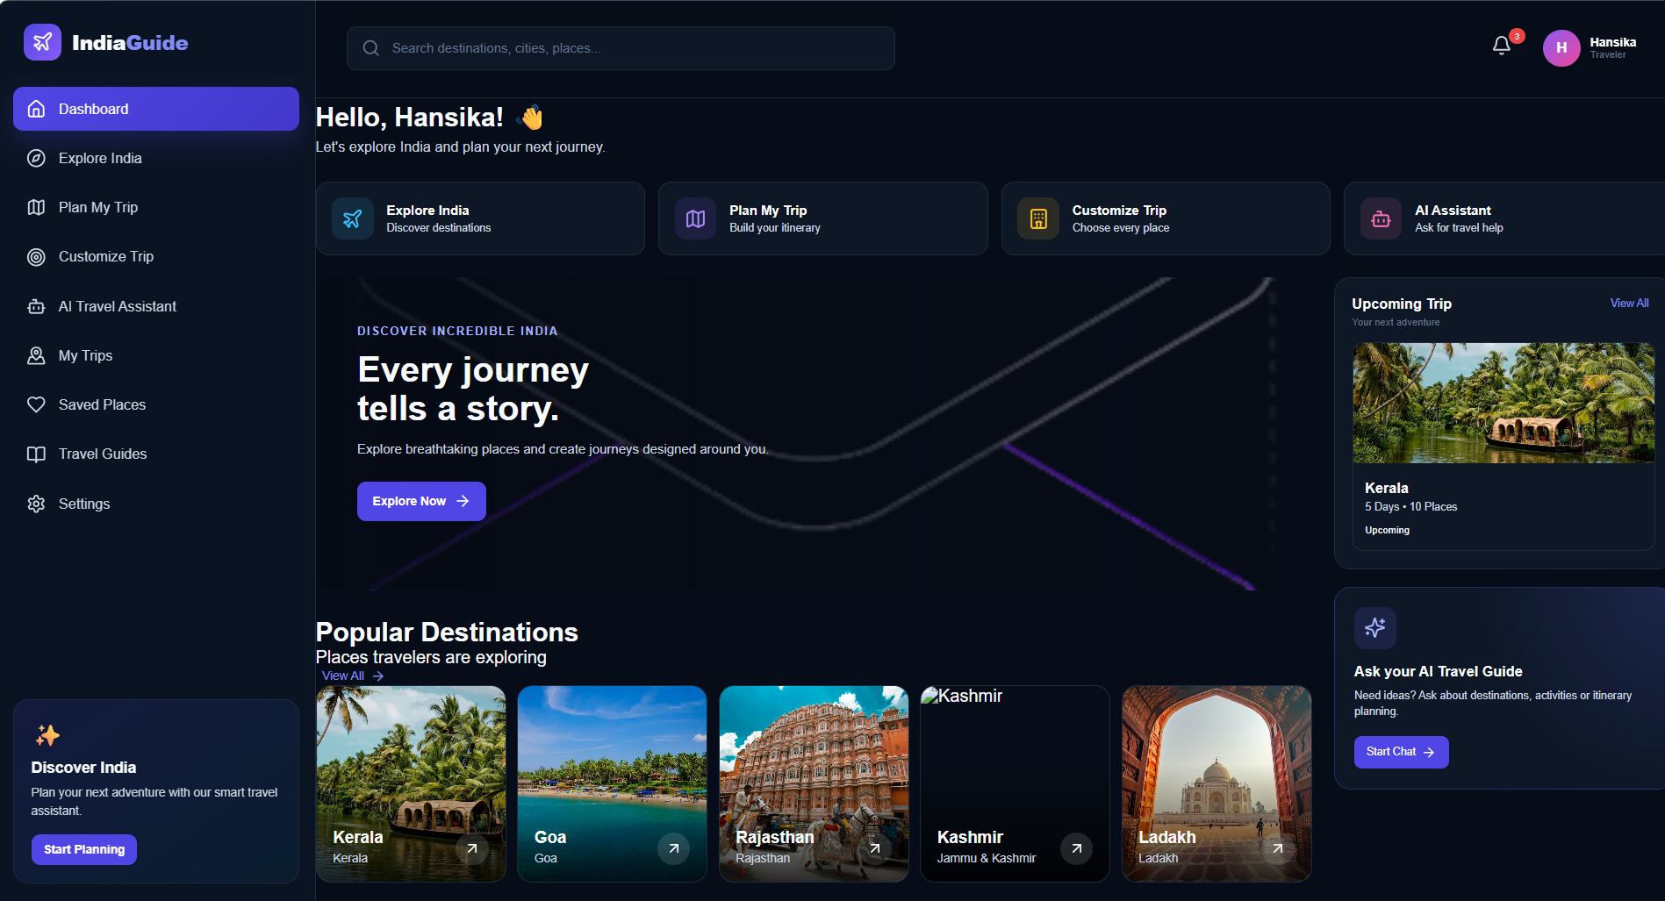
APPENDIX B – SYSTEM ARCHITECTURE DIAGRAM
This appendix presents the system architecture of the Tourist Guide application. The diagram shows the interaction between the user, Android application, Mapbox Offline, Room Database, LLM API, and external services.
APPENDIX C – DATABASE DESIGN
This appendix presents the Room Database design used for storing application data locally. It includes the main entities, fields, primary keys, relationships, and database components used for features such as Trip Journal, saved places, and local travel information.
APPENDIX D – SAMPLE CODE SNIPPETS
This appendix contains selected code snippets from the implementation of the Tourist Guide application. The snippets demonstrate important components such as Kotlin application logic, Mapbox integration, offline maps, Room Database, Retrofit API communication, LLM integration, and Trip Journal functionality.
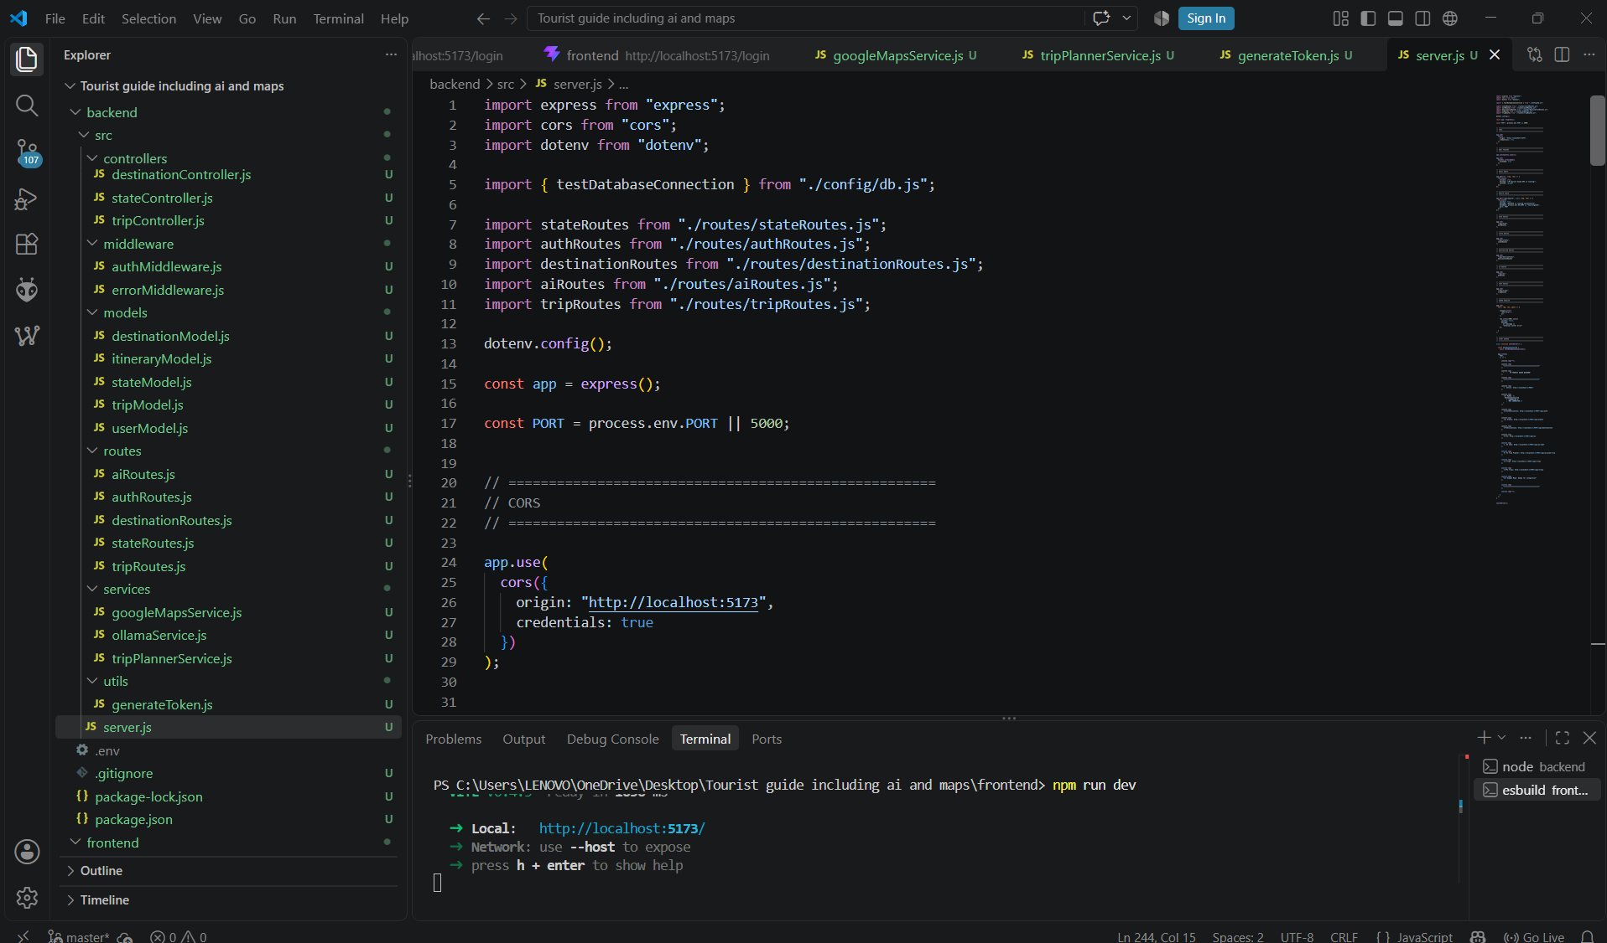
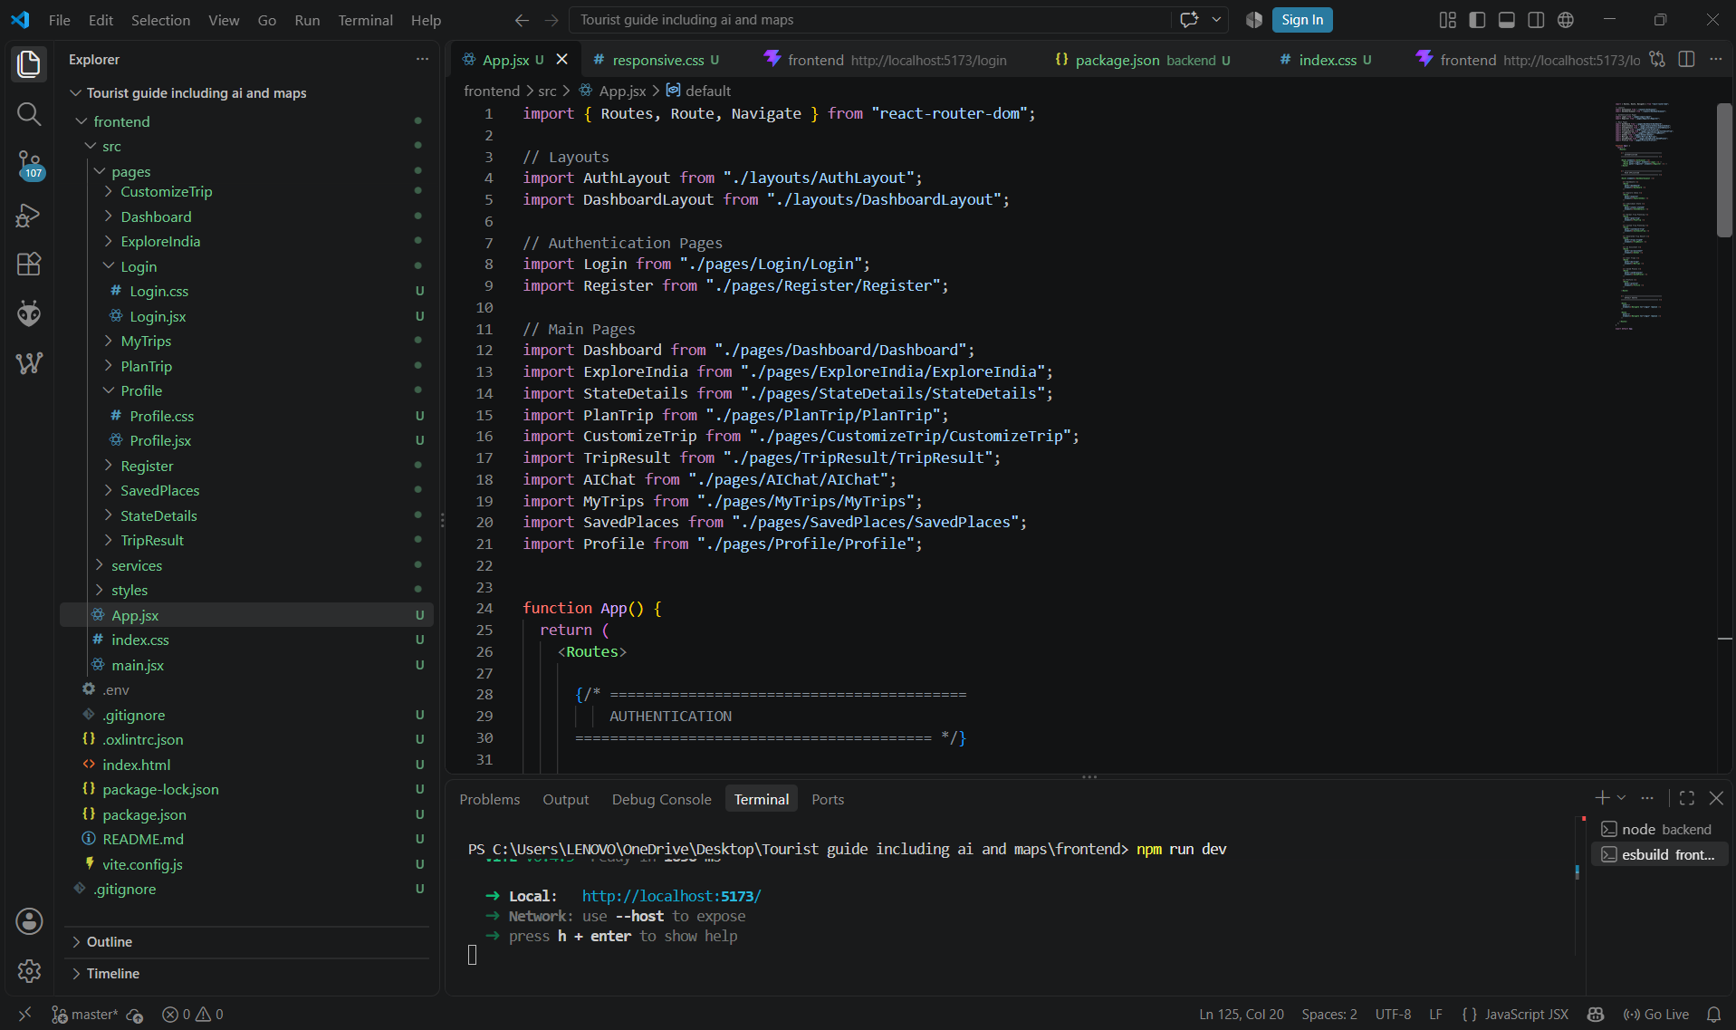
APPENDIX E – INSTALLATION AND SETUP INSTRUCTIONS
The Tourist Guide application can be developed and tested using Android Studio. The project should be opened in Android Studio, followed by configuration of the required Android SDK, dependencies, Mapbox credentials, and LLM API credentials.
After configuration, the application can be built and executed using an Android emulator or a physical Android device. Offline features can be tested by downloading the required map data and then disabling the internet connection.
APPENDIX F – USER MANUAL
The Tourist Guide application provides a simple interface for accessing different travel assistance features. Users can navigate through the application to access maps, explore points of interest, generate itineraries, view emergency information, access booking links, and maintain their Trip Journal.
The Offline Maps feature allows users to download maps for later use without internet connectivity. The AI Itinerary Chatbot generates travel plans based on the user's destination, duration, and interests, while the Trip Journal allows users to save and view their travel experiences.
APPENDIX G – TESTING EVIDENCE
This appendix contains screenshots and other evidence collected during the testing of the application. It includes evidence of map functionality, offline operation, POI exploration, API communication, AI chatbot testing, Room Database operations, and general application testing.
APPENDIX H – PROJECT OUTPUT
The final output of the project is an Android-based Tourist Guide application that combines offline maps, POI exploration, AI itinerary assistance, emergency information, booking links, Trip Journal, and locally stored travel information.
The project demonstrates the integration of Android, Kotlin, Mapbox, Room Database, Retrofit, and artificial intelligence to create an offline-first travel assistance system that provides useful travel support even when internet connectivity is limited.
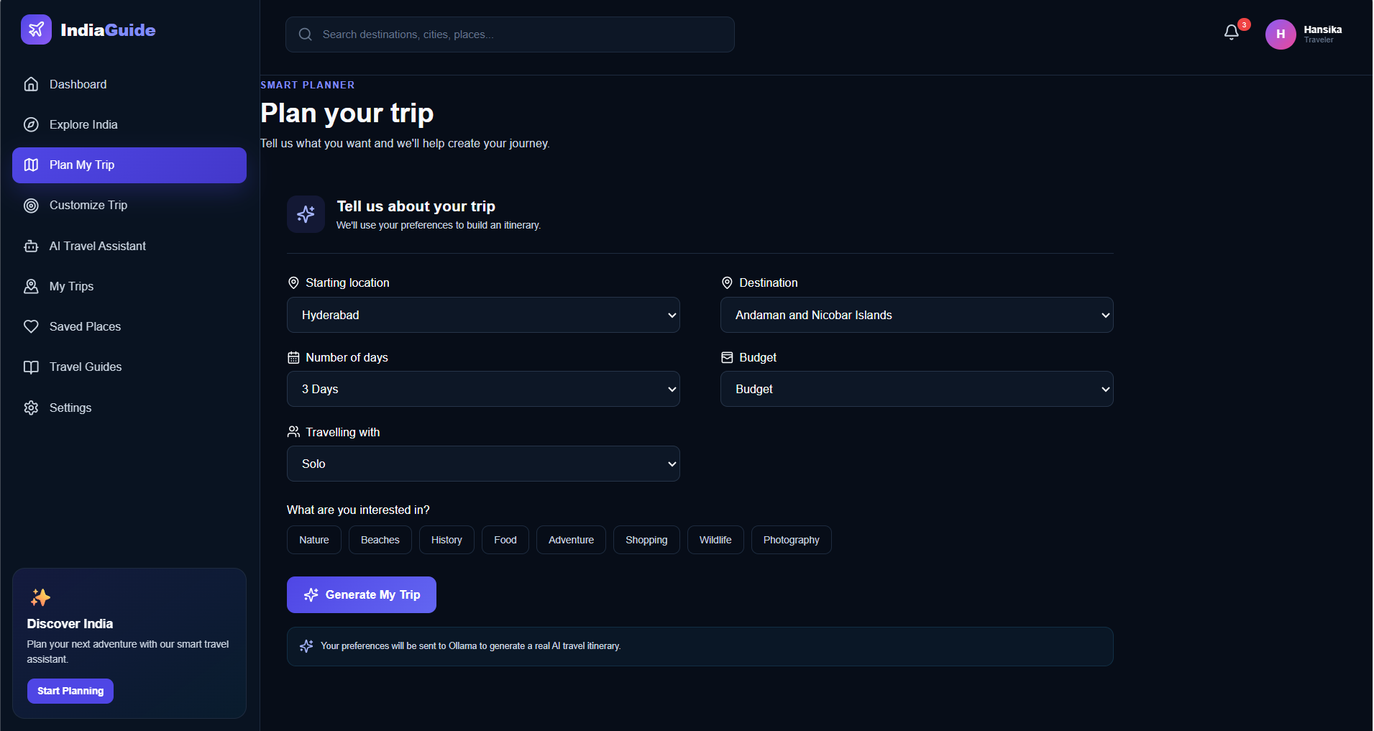
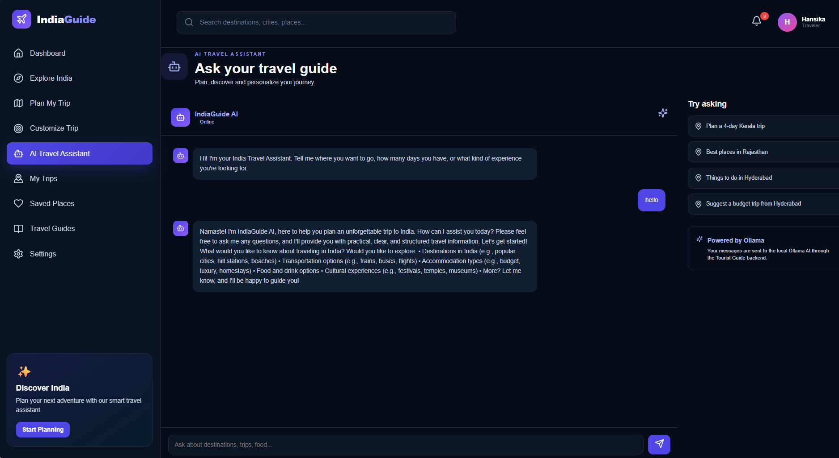

Geo Tag photos with guide
